Music Activity
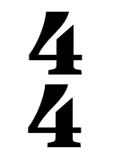
Step 1: Write some notes into the bar above which add up to FOUR beats.
Example: a crotchet equals 1 beat, so you could have 4 crotchets in your bar.
Step 2: Underneath each note, write one of the following letters: C, D, E, G or A.
Group 1: Your bar must BEGIN with a C.
Group 6: Your bar must END with a C.
WALT: Compose our own song.
TIB: Creating ways to express ourselves is important.
WILF: Groups working together to achieve this activity.

