Basic Arithmetic & Algebra
Decimals, Fractions & Percentages:
Decimal | Fraction | Percentage
0.1 | 1/10 | 10%
0.2 | 2/10 = 1/5 | 20%
0.25 | 25/100 = 1/4 | 25%
0.3333333.... | 1/3 | 33.333333... %
0.5 | 1/2 | 50%
0.75 | 75/100 = 3/4 | 75%
1.0 | 1/1 = 2/2 = 6/6 | 100%

Powers and Roots
Power (Index) | Expanded Notation
6⁵ | 6 x 6 x 6 x 6 x 6
3⁴ | 3 x 3 x 3 x 3

Index Laws
RULE | ACTIVITY
a^{m} x a^{n} = a^{(m + n)} | g⁴ x g⁵ =
a^{m}÷ a^{n} = a^{(m-n)} | g⁵ ÷ g³ =
(a^{m})^{n} = a^{mn} | (g⁵)⁴ =
(ab)^{n} = a^{n}b^{n} | (gf)⁴ =
${\left(\frac{a}{b}\right)}^{n}$= $\frac{a^{n}}{b^{n}}$ | $${\left(\frac{a}{b}\right)}^{6}=$$
a⁰ = 1 | (3b)⁰ =  3b⁰ =
a^{-n} = $\frac{1}{a^{n}}$ | a⁻⁶ =

Fractional Indices
RULE | ACTIVITY
$a^{\frac{3}{n}}$ = $\sqrt[n]{a^{3}}$ | $$f^{\frac{4}{5}}= \sqrt{}$$
$a^{\frac{-n}{m}}$= $\frac{1}{\sqrt[m]{a^{n}}}$ | $a^{\frac{-5}{6}}$=

Surds
Addition & Subtraction
Example: $3\sqrt{2}+ 4\sqrt{2}=7\sqrt{2}$
Harder Example: 4$\sqrt{48}+ 3\sqrt{147}$ + $5\sqrt{12}$
= (4 x $\sqrt{16}$ x $\sqrt{3}$) + ( 3 x $\sqrt{49}$ x $\sqrt{3}$) + (5 x $\sqrt{4}$ x $\sqrt{3}$)
= (4 x 4 x $\sqrt{3}$) + (3 x 7 $\sqrt{3}$) + (5 x 2 $\sqrt{3}$) = 16$\sqrt{3}$ + 21$\sqrt{3}$ + 10$\sqrt{3}$
= 47$\sqrt{3}$
Activity: Simplify $\sqrt{80}$ - 3$\sqrt{245}+ 2\sqrt{50}$

Multiplication & Division
RULE | ACTIVITY
$\sqrt{a } x \sqrt{b}$ = $\sqrt{ab}$ | $\sqrt{5 } x \sqrt{11}$ =
$c\sqrt{a } x d\sqrt{b}$ = $cd\sqrt{ab}$ | $3\sqrt{2 } x 4\sqrt{3}$ =
$\sqrt{a } x \sqrt{a}$ = $\sqrt{a^{2}}=a$ | $\sqrt{3 } x \sqrt{3}$ = $\sqrt{ }=$
$\frac{\sqrt{a}}{\sqrt{b}}$ = $\sqrt{\frac{a}{b}}$ | $\frac{\sqrt{10}}{\sqrt{5}}$ =

Rationalising the Denominator
HINT: Multiply by $\frac{\sqrt{4}+6}{\sqrt{4}+6}$
Example: Simplify $\sqrt{\frac{25}{3}}$
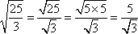
Activity: Simplify $\frac{3}{\sqrt{4}- 6}$
____________________________________________________________________________________________________________________________________________________________________________________________________________________________________________________________________
Factorising
Simple Factors: To factorise an expression we use the distributive law...
ax + bx = x(a + b)
Example: Factorise 3x + 12 = 3(x + 4)
Activity: Factorise
2y + 6
________________________________________________________________________________________________________________________________________________________________________________________________________________
2(y - 1) - y(y - 1)
________________________________________________________________________________________________________________________________________________________________________________________________________________
Grouping in Pairs: If an expression has 4 terms it may be factorised in pairs...
ax + bx + ay + by = x(a + b) + y(a + b)
= (a + b) (x + y)
Activity: Factorise
x² - 2x + 3x - 6 =
____________________________________________________________________________________________________________________________________________________________________________________________________________________________________________________________________
x⁴ + 7x³ - 4x - 28 =
____________________________________________________________________________________________________________________________________________________________________________________________________________________________________________________________________
Trinomials: A trinomial is an expression with three terms. Factorising a trinomial usually gives a binomial product.
x² + (a + b)x + ab = (x + a)(x + b)
Activity: Factorise y² - 10y + 21
____________________________________________________________________________________________________________________________________________________________________________________________________________________________________________________________________
Harder Trinomials
PSF Method of solving Trinomials with a Coefficient (number) in front of the first term.
Example: 5y² - 13y + 6
P: Product of first and last terms (5y² x 6 = 30y²)
S: Sum or middle term (-13y)
F: Factors of P that add to give S (-3y, -10y)
5y² - 13y + 6 = 5y² - 3y - 10y + 6
= y(5y - 3) - 2(5y - 3)
= (5y - 3)(y - 2)
Activity:
Factorise 6y² + 47y - 8
________________________________________________________________________________________________________________________________________________________________________________________________________________
____________________________________________________
Special Results
NAME | RULE
Perfect Squares | a² + 2ab + b² = (a + b)²
Perfect Squares | a² - 2ab + b² = (a - b)²
Difference of Two Squares | a² - b² = (a + b)(a - b)
Sum of 2 Cubes | a³ + b³ = (a + b)( a² - ab + b²)
Difference of 2 Cubes | a³ - b³ = (a - b)( a² + ab + b²)
Algebraic Fractions
RULE: Factorise First THEN Cancel.
Example: Simplify $\frac{2x^{2}- 3x-2}{x^{3}- 8}$
$=\frac{\left(2x+1\right)(x-2)}{\left(x-2\right)(x^{2}+2x+4)}=\frac{\left(2x+1\right)(x-2)}{\left(x-2\right)(x^{2}+2x+4)}= \frac{2x+1}{x^{2}+2x+4}$
Activity: Simplify $\frac{s^{2}+ s-2}{s^{2}+ 5s+6}$
____________________________________________________________________________________________________________________________________________________________________________________________________________________________________________________________________________________________________________________________________________________________________________
Solving Quadratic Equations
Solving By Factorisation
Example: Solve 5y² - 13y + 6 = 0
0= 5y² - 3y - 10y + 6
0= y(5y - 3) - 2(5y - 3)
0= (5y - 3)(y - 2)
To find the 2 possible solutions:
5y - 3 = 0 y - 2 = 0
5y = 3 y = 2
y = $\frac{3}{5}$
Solving by Quadratic Formula: For the equation ax² + bx + c = 0
$$x=\frac{-b±\sqrt{b^{2}-4ac}}{2a}$$
Activity: Using the Quadratic Formula solve 2x² - 7x + 1 = 0
________________________________________________________________________________________________________________________________________________________________________________________________________________________________________________________________________________________________________________________
Simultaneous Equations: Are used to find the Point(s) of Intersection of two or more lines.
Activity: Find the point of intersection for
(1) x² + 2x +1
(2) 8x - 6
________________________________________________________________________________________________________________________________________________________________________________________________________________________________________________________________________________________________________________________________________________________________________________________________________________________________________________________________________________________________________________________________________
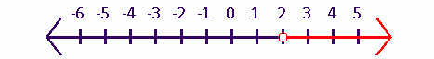
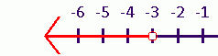
Quadratic Inequations
Example: Solve x² + x - 6 > 0
Step 1 Factorise: x² + x - 6 = 0
(x - 2)(x + 3) = 0
x = 2 or -3
Step 2: Test Results
Choose a number between - 3 and 2 (x = 0) and substitute it into the equation.
0² + 0 - 6 > 0 (-6 ≯ 0) ∴ The solution lies either side of -3 and 2.
Activity: Solve and graph $\frac{1}{y+1}>2$
_______________________________________________________________________________________________________________________________________________________________________________________________________________________________________________________________________________________________________________________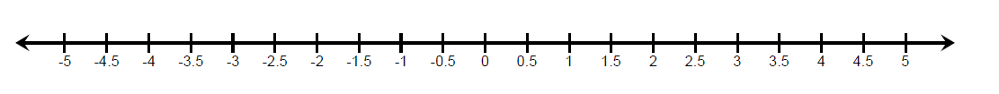
Revision Topic Test - Past HSC Questions
1. Factorise x² + 5x - 6 (2 marks)
________________________________________________________________________________________________________________________________________________________________________________________________________________________________________________________________________________________________________________________
2. Solve 4x + 7 = 3(x - 2) (2 marks)
____________________________________________________________________________________________________________________________________________________________________________________________________________________________________________________________________
3. Find log₁₀ (2¹⁰⁰⁰) correct to 3 decimal places. (2 marks)
________________________________________________________________________________________________________
4. We know that 2¹⁰ = 1024, so that 2¹⁰ can be represented by a 4 digit numeral. How many digits are there in 2¹⁰⁰⁰ when written as a numeral? (1 mark)
________________________________________________________________________________________________________

NB. Have this checked by your tutor/teacher. Initial:
Date:
Plane Geometry
Abbreviations
Symbol | Meaning | Example | In Words
 | Triangle | ABC has 3 equal sides | Triangle ABC has three equal sides
 | Angle | ABC is 45° | The angle formed by ABC is 45 degrees.
 | Perpendicular | ABCD | The line AB is perpendicular to line CD
 | Parallel | EFGH | The line EF is parallel to line GH
 | Degrees | 360° makes a full circle
 | Right Angle (90°) | is 90° | A right angle is 90 degrees
 | Congruent (same shape and size) | ABC DEF | Triangle ABC is congruent to triangle DEF
 | Similar (same shape, different size) | DEFMNO | Triangle DEF is similar to triangle MNO
 | Therefore | a=b b=a | a equals b, therefore b equals a

Types of Angles
Angle | Picture | Rule
Alternate Angle | 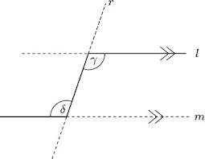 | Alternate Angles are Equal
Corresponding Angles | 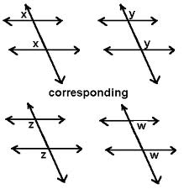 | Corresponding Angles are Equal
Co-interior Angles | 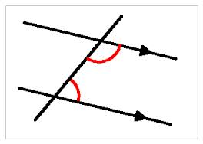 | Co-interior Angles are Supplementary (aka they add to 180⁰)
Vertically Opposite Angles | 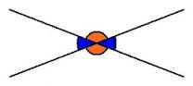 | Vertically opposite angles are equal.
Straight Line Angles | 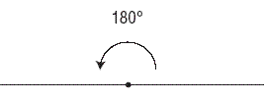 | Straight line angles add to give 180⁰
Right Angles | 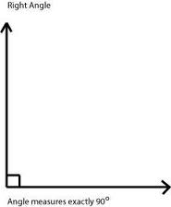 | Right angles add to give 90⁰

Activity:
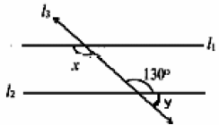
Line l₃ is a transversal to the parallel lines l₁ and l₂. Find the value of x and y (Give reasons).
________________________________________________________________________________________________________________________________________________________________________________
Types of Triangles
Name | Picture | Characteristics
Equilateral | 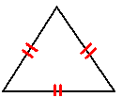 | All equal sides and angles.
Scalene | 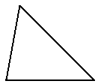 | No equal sides and angles
Isosceles | 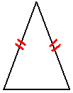 | Two equal sides with corresponding equal angles.
Right Triangle | 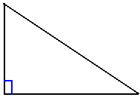 | Triangle with a right angle.
Angle Sum of a Triangle
The sum of the interior angles in any triangle is 180⁰
Exterior Angle of a Triangle
The exterior angle of any triangle is equal to the sum of the two opposite interior angles.
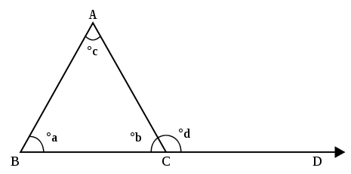
aº + cº = dº
Congruent Triangles
Two triangles are congruent if they are exactly the same shape and size. All pairs of corresponding sides and angles are equal.
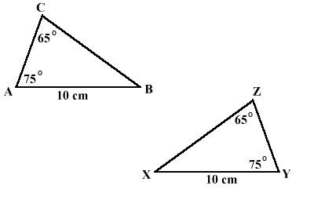
Congruency Tests
SSS | All 3 pairs of corresponding sides are equal.
SAS | Two pairs of corresponding sides and their included angles were equal.
AAS | Two pairs of angles and one pair of corresponding sides are equal.
RHS | Both have a right angle, their hypotenuses are equal and one other pair of corresponding sides are equal.
Activity: Circle the pairs of triangles that are congruent. If they are congruent what test would you use to prove them congruent.
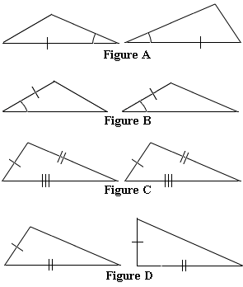
Similar Triangles
Triangles are similar if they have the same angles but different sized sizes that are in proportion to one another.
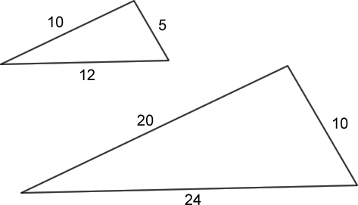

Similarity Tests
Two triangles are similar if:
- 3 pairs of corresponding angles are equal.
- 3 pairs of corresponding sides are in proportion.
- 2 pairs of sides are in proportion and their included angles are equal.

Activity: Are these triangles similar? If so find h to 1 decimal place (Give reasons)
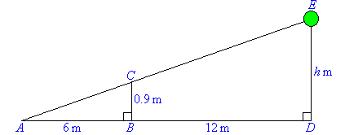
____________________________________________________
____________________________________________________
____________________________________________________
____________________________________________________
____________________________________________________
____________________________________________________
Types of Quadrilaterals
A quadrilateral is any four-sided figure.
The angle sum of all quadrilaterals is 360º.
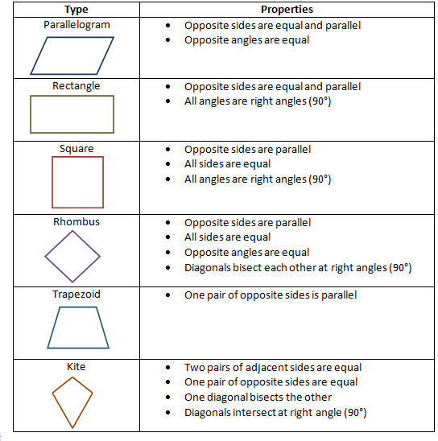
Activity: Find the sizes of the unknown angles in the trapezium (give reasons).
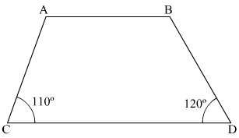
aº bº
____________________________________________________________________________________________________________________________________________________________________________________________________________________________________________________________________________________________________________________________________________________________________________
Question: Name all the quadrilaterals with at least one set of parallel sides.
________________________________________________________________________________________________________________________________________________________________________________________________________________
Polygons
A polygon is a plane figure with straight sides. A regular polygon has equal sides and interior angles.
The sum of interior angles in an n-sided polygon is
S = (2n - 4) x 90º
The sum of the exterior angles of any polygon is 360º
Shape | Picture | Number of Sides | Interior Angle Sum
Triangle | 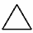 | 3 | 180⁰
Quadrilateral  (Any 4-sided shape) | 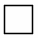 | 4 | 360⁰
Pentagon | 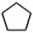 | 5 | 540⁰
Hexagon |  | 6 | 720⁰
Heptagon | 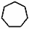 | 7 | 900⁰
Octagon | 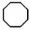 | 8 | 1080⁰
Example: Find the size of an interior angle of a regular hexagon.
Angle sum of an n-sided polygon = (2n – 4) right angles.
∴ Angle sum of a hexagon = 8 right angles = 720°.
∴ Size of each angle = 720° ÷ 6 = 120°.
Activity: Sketch the following polygons and record their area formulae.
Name | Sketch | Area Formula
Rectangle
Square
Triangle
Parallelogram
Rhombus
Trapezium
Circle
Revision Topic Test - Past HSC Questions
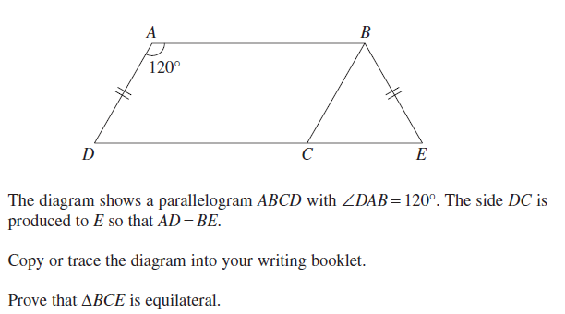
(3 marks)
____________________________________________________________________________________________________________________________________________________________________________________________________________________________________________________________________________________________________________________________________________________________________________________________________________________________________________________________________________________________________________________________________________________________________________________________

Probability
Simple Probability: To find the probability that a certain event will occur, compare the number of ways it can happen with the number of outcomes.
$$P\left(E\right)= \frac{Number of ways an event can occur}{Total number of all possible outcomes}$$
Example: A bag contains 5 blue marbles, 3 white marbles and 7 yellow marbles. If one marble is taken out of the bag at random what is the probability of getting:
a) A white marble $\frac{3}{15}$
b) A white OR blue marble $\frac{8}{15}$
c) A yellow, white OR blue marble $\frac{15}{15}=1=Certain$
d) A red marble $\frac{0}{15}=0=Impossible$
Random events: Probability can be measured in theory as long as the events are random. This means there can be no bias towards one event or another.
Equally Likely Outcomes: Probability cannot be measured if the outcomes are not equally likely.
Activity: A biased coin is weighted so that heads comes up twice as often as tails. Find the probability of tossing a tail.
________________________________________________________________________________________________________________________________________________________________________________________________________________
Complementary Events
When we are finding the probabilities of events the total of all possible events adds up to 1.
The compliment of an event happening is the event not happening. That is the complement of P(E) is P(not E).
Example: A dice is thrown. Find the probability of
a) Throwing a 6
ANSWER: $\frac{1}{6}$
b) Not throwing a 6
ANSWER: 1 - $\frac{1}{6}$ = $\frac{5}{6}$
Activity: The probability of a bus arriving on time is estimated at $\frac{18}{33}$. What is the probability the bus will not arrive on time?
____________________________________________________________________________________________________________________________________________________________
Non-mutually-exclusive Events
Non-mutually-exclusive events have some overlap (more than one event can happen at the same time). It is important to count the events carefully.
Example: One card is drawn from a set of cards numbered 1 to 10. Find the probability of drawing out an odd number or a multiple of 3.
8 10

2 4
Odd
1 3
5 9
7
Multiples of 3
6
A Venn Diagram can be handy for these questions.
P(Odd OR Multiple) = $\frac{6}{10}$

Rolling 2 Dice
When 2 dice are rolled, a table of all possible outcomes can be made. Results are the same whether the dice are rolled at the same time or one after the other.
 | 1 | 2 | 3 | 4 | 5 | 6
1 | 1,1 | 1,2 | 1,3 | 1,4 | 1,5 | 1,6
2 | 2,1 | 2,2 | 2,3 | 2,4 | 2,5 | 2,6
3 | 3,1 | 3,2 | 3,3 | 3,4 | 3,5 | 3,6
4 | 4,1 | 4,2 | 4,3 | 4,4 | 4,5 | 4,6
5 | 5,1 | 5,2 | 5,3 | 5,4 | 5,5 | 5,6
6 | 6,1 | 6,2 | 6,3 | 6,4 | 6,5 | 6,6
Activity: Two dices are rolled. Find the probability of rolling:
a) Double 6
__________________________________________
b) A 5 and a 6
__________________________________________
c) At least one 1
__________________________________________
d) At least one 2 or 3
__________________________________________
Product Rule
When more than one event occurs (eg. tossing two coins) multiply the probabilities together.
P(AB) = P(A) x P(B)
Example: If 2 dice are thrown find the probability of throwing two 6's.
P(2 sixes) = P(1 six) x P(1 six)
P(2 sixes) = $\frac{1}{6} x \frac{1}{6} = \frac{1}{36}$

Tree Diagrams
When there is more than one possible result (HT or TH) we add them together.
P(A or B) = P(A) + P(B)
Below is a tree diagram for the outcomes if 2 coins were tossed.
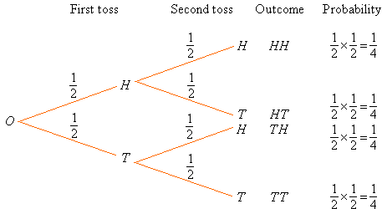
Activity: What is the probability of:
a) Tossing at least one Head? ____________________
____________________________________________
____________________________________________
Tossing no Heads? ____________________________
________________________________________________________________________________________
Revision Topic Test - Past HSC Questions
By drawing a Tree Diagram solve the following problem. If you toss a coin and roll a die, what is the probability of obtaining:
a) A head and a five
b) A head or a five
c) A Tail or a two

Real Functions
Function vs Relation
A relation is a set of ordered pairs (aka it can be plotted on a number line).
A function is a special type of relation in which for every x value there is one corresponding y value.
In order to test whether a set of ordered pairs is a function or relation we use the vertical line test.
Function Relation
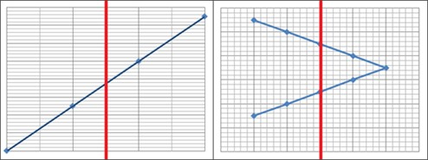
If the vertical line goes through the line only once anywhere along the line, the graph is a function.
If the vertical line goes through the line twice, the graph is a relation because there is not one-to-one correspondence.

Activity: Label the following graphs function or relation.
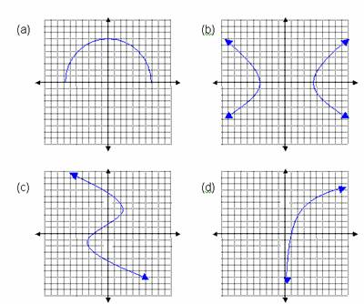
Function Notation
If y is a function of x, than we write y = f(x)
Example: If f(x) = x² + 3x + 1, find f(-2)
Solution: f(-2) = (-2)² + 3(-2) + 1
= 4 - 6 + 1
= -1
Activity: If f(x) = 3x² - 2x + 4, find f(4)
________________________________________________________________________________________________________Activity: If f(x) = 4x² + 3x - 7, find f( -6) ________________________________________________________________________________________________________
Odd & Even Functions
For even functions f(x) = f(-x)
For odd functions f(-x) = -f(x)
Example: Prove whether f(x) = x² + 3 is an even or odd function.
Solution: Test for even functions...
f(x) = f(-x)
x² + 3 = (-x)² + 3
x² + 3 = x² + 3
Therefore it is an even function.
The x-intercept and y-intercept
The x-intercept is where the graph cuts the x-axis.
To find the x-intercept put y=0
The y-intercept is where the graph cuts the y-axis.
To find the y-intercept put x=0
Activity: Find the x and y intercepts for
a) y = x - 3 ___________________________________________
____________________________________________________________________________________________________________________________________________________________
b) y = 5x + 20_________________________________________
____________________________________________________________________________________________________________________________________________________________
c) x - 2y = 6 __________________________________________
____________________________________________________________________________________________________________________________________________________________
Domain & Range
The domain is all the set of possible x values.
The range is all the possible y values.
Example: Find the domain and range of y = x + 1
Solution: Any value can be substituted for x
∴ the domain is all real x values.
Any number is possible for y
∴ the range is all real y values
Activity: What is the domain and range of y = x² + 1
________________________________________________________________________________________________________________________________________________________________________________________________________________Activity: What is the domain and range of y = $\frac{1}{x+1}$
________________________________________________________________________________________________________________________________________________________________________________________________________________
Straight Line Graphs
The graph of a straight line has the form:
ax + by + x = 0 (General Form)
y = mx + b (Gradient Form)
To sketch a graph follow these steps:
- Work out the x and y intercepts.
- Create a table of values between the two intercepts.
- Plot the intercepts and other points on the graph and join them up.
The Parabola
A graph in the form y= ax² + bx + c has the shape of a parabola.

If the coefficient (number) in front of the x² is positive the parabola is concave up and has a minimum point.
If the coefficient (number) in front of the x² is negative the parabola is concave down and has a maximum point.

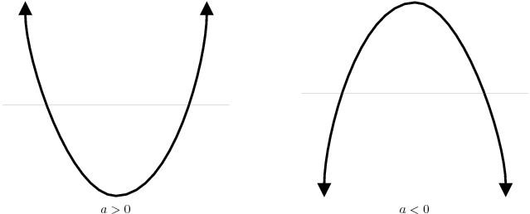
To sketch a parabola, use a table of values to plot the points and join with a gentle curve.
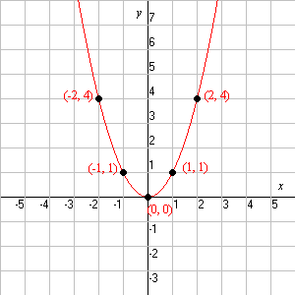
Example: Sketch y = x²
Solution:
x | -2 | -1 | 0 | 1 | 2
y | 4 | 1 | 0 | 1 | 4

Activity: Sketch y = x² + 3
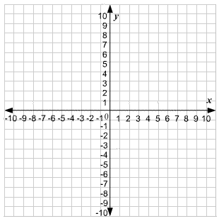
Domain and Range
Example: Find the domain and range of y = 2x² - 5
Solution: Because x² will always have to be positive the lowest value for x² is 0. So the Lowest value for 2(0) - 5 = -5
∴ The range is all real y ≥ -5
The x value can be any number value positive or negative.
∴ The domain is all real x.

The Circle
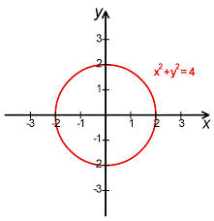
The graph whose equation is in the form x² + ax + y² + by + c = 0 has the shape of a circle.
The equation of a circle with radius r and centre (0,0) is x² + y²=r²
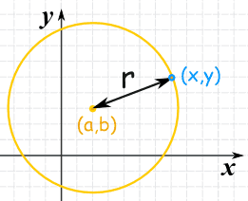
The equation of a general circle with radius r and centre (a,b) is given by
(x - a)² + (y - b)² = r²

Example: Sketch the curve (x - 1)² + (y + 2)² = 9
The centre is (a, b) or (1, -2) and the radius is r² = 9 so r = $\sqrt{9}$ = 3
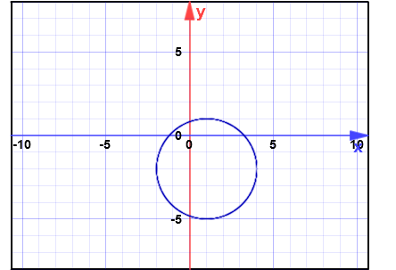

The Semi-circle
Given that x² + y² = r² is a circle with radius r and centre (0,0)
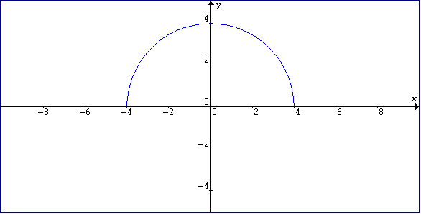
y² = r² - x²
y = ± $\sqrt{r^{2}- x^{2}}$
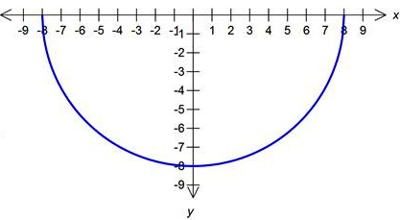
A semi-circle ABOVE the x-axis has the equation
y = $\sqrt{r^{2}- x^{2}}$ (y>0)
A semi-circle BELOW the x-axis has the equation
y = - $\sqrt{r^{2}- x^{2}}$ (y<0

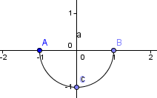
Example: Sketch y = - $\sqrt{1- x^{2}}$
Solution: This equation describes a semicircle BELOW the x-axis with radius 1 and centre (0,0).
Activity: Sketch y = $\sqrt{9- x^{2}}$

Graphs Involving Absolute Values
To solve and graph an absolute values function use a table of values.
Example: Sketch y = |x - 2|
Solution: Table of Values
x | -3 | -2 | -1 | 0 | 1 | 2 | 3 | 4
y | 5 | 4 | 3 | 2 | 1 | 0 | 1 | 2
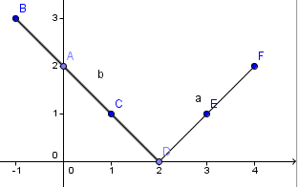
Activity: Sketch y = |3x| - 2

The Hyperbola
The hyperbola is a function with its equation in the form xy = a or y = $\frac{a}{x}$
Example: Sketch y = $\frac{1}{x}$
Solution: y = $\frac{1}{x}$ is a discontinuous curve since the function has no value at x=0.
x | -3 | -2 | -1 | -$\frac{1}{2}$ | -$\frac{1}{4}$ | 0 | $$\frac{1}{4}$$ | $$\frac{1}{2}$$ | 1 | 2 | 3
y | -$\frac{1}{3}$ | -$\frac{1}{2}$ | -1 | -2 | -4 | - | 4 | 2 | 1 | $$\frac{1}{2}$$ | $$\frac{1}{3}$$

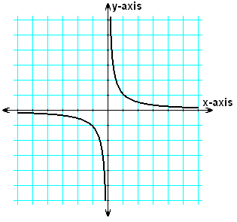
Locus
A locus is the term used to describe the path of a single moving point that obeys certain conditions.
Example: Describe the locus of a pencil on the end of compasses.
Solution: The path of the pencil is a circle with centre at the point of the compasses.
Example: A point on the number line that is 3 units from 0.
Solution: The locus is ±3 because both positive and negative 3 are 3 units from 0.
Regions
A line on the number plane divides it into different regions.
Example: Sketch x ≤ 3.
Solution: First sketch x=3 on a graph. Look along the x-axis, shade all the points where x< 3.

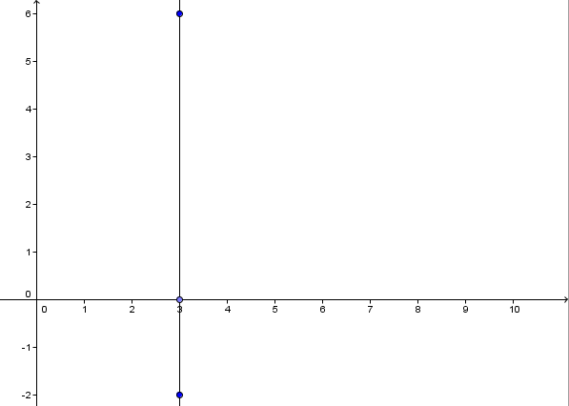
Revision Test - Past HSC Questions
1. Shade the region defined by y < x + 1

2. Sketch y = (x + 2)² - 1 in the domain - 3 ≤ x ≤ 0

3. Find the equation of the locus of a point moving in the number plane so that it is always 4 units from the origin.

Trigonometry
Trigonometric Ratios
Sine | sinθ | =$\frac{opposite}{hypotenuse}$
Cosine | cosθ | =$\frac{adjacent}{hypotenuse}$
Tangent | tanθ | =$\frac{opposite}{adjacent}$
Cosecant | cosecθ | =$\frac{hypotenuse}{opposite}$ | $$\frac{1}{sinθ}$$
Secant | secθ | =$\frac{hypotenuse}{adjacent}$ | $$\frac{1}{cosθ}$$
Cotangent | cotθ | =$\frac{adjacent}{opposite}$ | $$\frac{1}{tanθ}$$

Complementary Angles
Sine θ | =cos(90⁰ - θ)
Cosine θ | =sin(90⁰ - θ)
Tangent θ | =cot(90⁰ - θ)
Cosecant θ | =sec(90⁰ - θ)
Secant θ | =cosec(90⁰ - θ)
Cotangent θ | =tan(90⁰ - θ)

Rounding Off Angles
60 minutes | = 1 degree | (60' = 1⁰)
60 seconds | = 1 minute | (60" = 1')

If the minute or second is below 30 it stays the same, if it is above 30 you round up.

Finding a Missing Variable
Trigonometry is used to find an unknown side or angle of a triangle.
Activity: Find θ to the nearest degree.
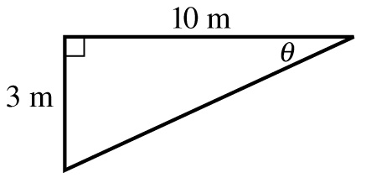

Activity: Find the value of x.
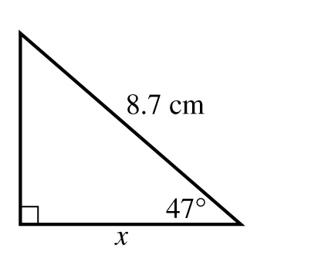
Activity: For the following, evaluate θ correct to the nearest minute, sin θ = 0.422

Activity: Identify the complementary angle of Cosec 47⁰

Angle of Elevation
The angle of elevation is used to measure the height of tall objects that cannot be measured directly, for example a tree, cliff, tower or building.
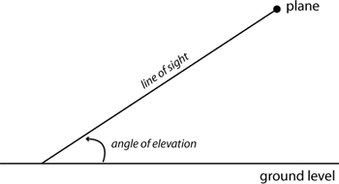
Angle of Depression
The angle of depression is the angle formed when looking down from a high place to an object below.
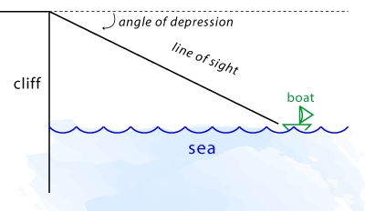

Activity: The angle of depression from the top of a 20m building to a boy below is 61⁰39'. Draw a diagram and determine how far is the boy from the building to 1 decimal place?

Activity: The angle of elevation of a tower is 39⁰44' when measured at a point 100m from its base. Draw a diagram and find the height of the tower, to 1 decimal place.

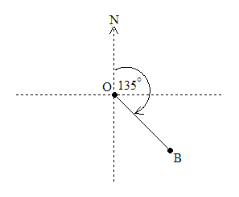
Bearings
True bearings measure angles in a clockwise direction beginning at north.
Example: Sketch the diagram when B is on a bearing of 135⁰ from O.
Solution: See figure 1

Figure 1
Activity: Sketch the diagram of A is on a bearing of 245⁰ from B.

Activity: A plane flies north from Sydney for 560km, then turns and flies east for 390km. What is its bearing from Sydney, to the nearest degree?

Exact Ratios
A right angles triangle with one angle of 45⁰ is isosceles. The exact length of its hypotenuse can be found.
 | 30⁰ | 45⁰ | 60⁰
sinθ | $$\frac{1}{2}$$ | $$\frac{1}{\sqrt{2}}$$ | $$\frac{\sqrt{3}}{2}$$
cosθ | $$\frac{\sqrt{3}}{2}$$ | $$\frac{1}{\sqrt{2}}$$ | $$\frac{1}{2}$$
tanθ | $$\frac{1}{\sqrt{3}}$$ | 1 | $$\sqrt{3}$$

Activity: Find the exact values in all questions.
- sin60⁰ + cos60⁰ =

- cosec45⁰ =
- 2 sec60⁰ =
- cot30⁰ + cot60⁰ =

Angles of Any Magnitude
Positive angles are measured in an anti-clockwise direction.
Negative angles are measured in a clockwise direction.
-270⁰
90⁰
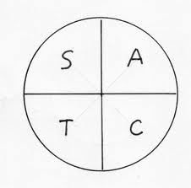
4th Quadrant
3rd Quadrant
2nd Quadrant
1st Quadrant
-90⁰
270⁰
-180⁰
180⁰
0⁰
360⁰
Example: Find the exact values of cos150⁰
cos150⁰ = cos(180⁰ - 30⁰)
= -cos(30⁰) [cos is negative in the second quadrant]
= - $\frac{\sqrt{3}}{2}$
Example: Find the exact values of cos(-210⁰)
cos(-210⁰) = cos150⁰
= - $\frac{\sqrt{3}}{2}$ [ As proven previously]
Activity: If tanθ = $\frac{3}{4}$ and cosθ < 0, find sinθ and cosθ as a rational number.
________________________________________________________________________________________________________________________________________________________________________________________________________________________________________________________________________________________________________________________
Trigonometric Equations
A trigonometric equations involves finding an angle whose trigonometric ratio is given. If the angles can lie in all 4 quadrants, that is, 0⁰ ≤ θ ≤ 360⁰; there is usually more than one solution to an equation.
Example: Solve sin θ = $\frac{1}{2}$ for 0⁰ ≤ θ ≤ 360⁰
Solution: We need to find the angle whose sin = $\frac{1}{2}$
Sin is positive in the first and second quadrants, so there are two solutions.
sin θ = $\frac{1}{2}$
θ = 30⁰, 180⁰ - 30⁰
θ = 30⁰, 150⁰

Activity: Solve for 0⁰ ≤ θ ≤ 360⁰
(a) tan θ = -1

(b) 2 cos θ = $\sqrt{3}$

(c) 2 sin 3θ = -1

Trigonometric Graphs
y = sin x | 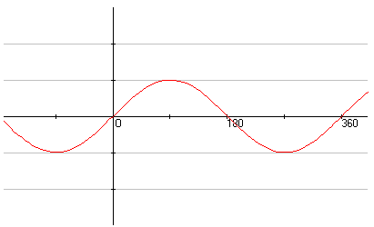
y = cos x | 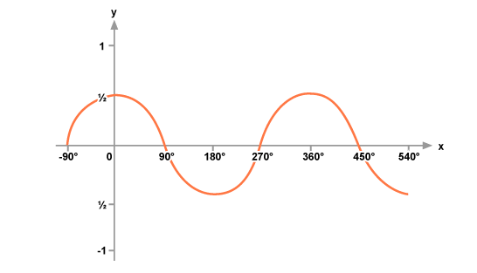
y = tan x | 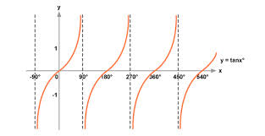

Example: Identify the domain of the graphs below.
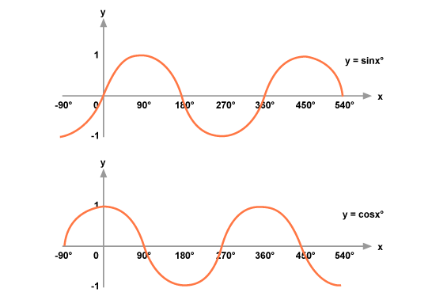
-90⁰ ≤ θ ≤ 540⁰
-90⁰ ≤ θ ≤ 540⁰

Activity: Sketch y = cos x for 0⁰ ≤ θ ≤ 360⁰

Trigonometric Identities
tan θ = $\frac{\sin{θ}}{\cos{θ}}$
cot θ = $\frac{\cos{θ}}{\sin{θ}}$
sin² θ + cos² θ = 1
1 + cot² θ = cosec² θ
tan² θ + 1 = sec² θ
Example: Simplify tan θ cos θ
Solution: tan θ cos θ = $\frac{\sin{θ}}{\cos{θ}}$ x $\frac{\cos{θ}}{1}$ = sin θ

Activity: Simplify tan θ cosec θ
________________________________________________________________________________________________________________________________________________________________________________________________________________________________________________________________________________________________________________________
Activity: Simplify sec θ cot θ
________________________________________________________________________________________________________________________________________________________________________________________________________________________________________________________________________________________________________________________
Example: Prove that cos² θ - 1 = -sin² θ
Solution: cos² θ - 1 = -sin² θ
cos² θ + sin² θ - 1 = 00

Non-right-angled Triangles
There are two rules in trigonometry that refer to right-angled-triangles; the Sine and Cosine Rule.
Sine Rule
$\frac{SinA}{a}= \frac{SinB}{b}= \frac{SinC}{c}$ (To find an angle)
$\frac{a}{SinA}= \frac{b}{SinB}= \frac{c}{SinC}$ (To find a side)
Example: Find the value of b⁰ correct to the nearest degree.
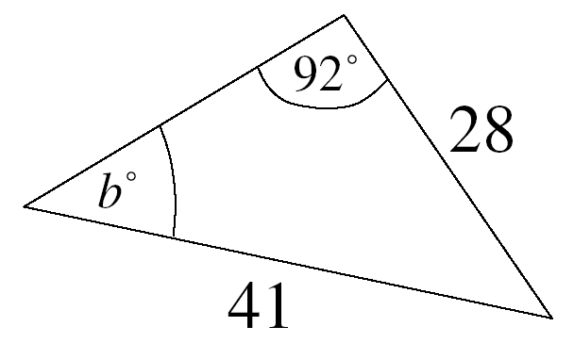
Solution: $\frac{Sin92}{41}= \frac{SinB}{28}$
$\frac{28 x Sin92}{41}= \frac{SinB}{1}$
Sin B = 0.682510808
Sin⁻¹ (0.682510808) = 43⁰2'24.57"
43⁰ (to nearest degree)
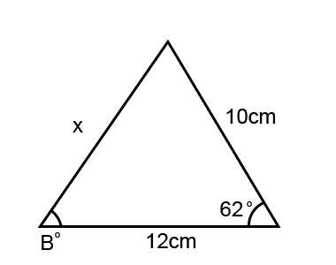
Cosine Rule
$$CosA= \frac{b^{2}+ c^{2}- a^{2}}{2bc} (To find an angle)$$
$$a^{2}= b^{2}+ c^{2}- 2bcCosA (To find a side)$$
Example: Find x to 1 decimal place.
Solution: $a^{2}= b^{2}+ c^{2}- 2bcCosA$
x² = 10² + 12² - 2 x 10 x 12 x Cos62⁰
x² = 100 + 144 - 240Cos62⁰
= 131.3268249 cm
= 131.3 cm (to 1 dp)
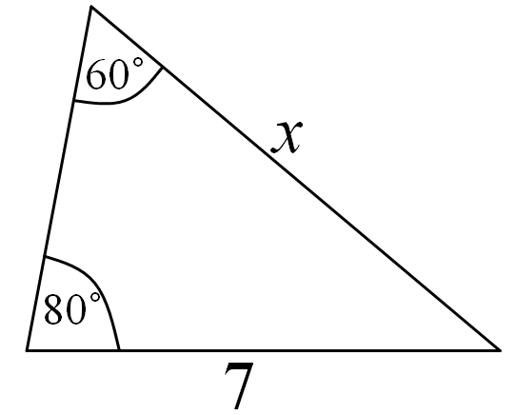
Activity: Find x to 1 decimal place.
____________________________________________________________________________________________________________________________________________________________________________________________________
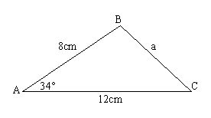
Activity: Find x to 1 decimal place.
________________________________________________________________________________________________________________________________________________________________________
Activity: A submarine is being followed by two ships, A and B which are 3.8km apart, with A due east of B. If A is on a bearing of 165⁰ from the submarine and B is on a bearing of 205⁰ from the submarine. Find the distance from the submarine to both ships.
__________________________
__________________________
__________________________
__________________________
__________________________
__________________________
__________________________
__________________________
__________________________
Area of a Non-Right-Angled Triangle
To find the area of a triangle, you need to know its perpendicular height.
$$A= \frac{1}{2}ab SinC$$
Example: Find the area of ∆ABC correct to 2 decimal places.
Solution: $A= \frac{1}{2}bc SinA$
= $\frac{8 x 12}{2} x Sin {34}^{0}$
= 48 Sin 34⁰
= 26.84125937 cm²
= 26.84cm² (to 2 dp)
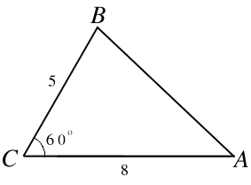
Activity: Find the area of ∆ABC correct to 1 decimal place.
________________________________________________________________________________________________________________________________________________________________________________________________________________________________

Revision Test - Past HSC Questions
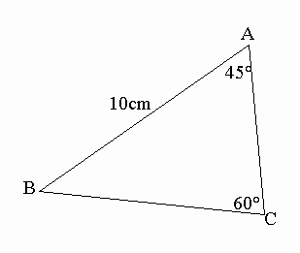
1. Use the Sine Rule to calculate the length of the side BC to the nearest centimetre.
______________________________________________________________________________________________________________________________________________________________________________________________________________________________________
2. A triangle ABC is right-angled at B. D is the point on AC such that BD is perpendicular to AC. Let angle BAC = 0
(a) Draw a diagram showing this information.

Linear Functions and Lines
Distance Formula
The distance between 2 points is easy to find when the points form a vertical or horizontal line.
$d= \sqrt{{(x_{2}- x_{1})}^{2}+ {(y_{2}- y_{1})}^{2}}$
Mid Point Formula
The midpoint is the point halfway between two other points.
$$P=\left(\frac{x_{1}+ x_{2}}{2},\frac{y_{1}+ y_{2}}{2}\right)$$
Gradient Formula
The gradient of a straight line measures its slope. The gradient compares the vertical rise with the horizontal run.
$$Gradient= \frac{Rise}{Run}$$
Gradient Given Two Points
This formula can be used for finding the gradient of a line provided you have two of the points which lie upon that line.
$$m= \frac{y_{2}- y_{1}}{x_{2}- x_{1}}$$
Gradient Given the Angle at the x-axis
The gradient of a straight line is given by
$$m=\tan{θ}$$
where θ is the angle the line makes with the x-axis in a positive direction.
Activity: Find the exact length of the interval between points (2,3) and (-1,1).
________________________________________________________________________________________________________________________________________________________________________________________________________________
Activity: Prove that the origin is the midpoint of (3,-4) and (-3,4).
____________________________________________________________________________________________________________________________________________________________________________________________________________________________________________________________________
Activity: The gradient of the points (2,-1) and (x,0) is -5. Find the value of x.
________________________________________________________________________________________________________________________________________________________________________________________________________________________________________________________________________________________________________________________________________________________________________________________________________________________________
Activity: Find the gradient of the straight line that makes an angle of 45⁰ with the x-axis in the positive direction.
________________________________________________________________________________________________________________________________________________________________________________________________________________
Gradient Given an Equation
To find the Equation of a Line (EOL) there are a few methods:
General Formula
The gradient of the line ax + by + c = 0 is given by m = $-\frac{a}{b}$
Example: Find the gradient of the straight line with the equation y = 4x
Solution: m = $-\frac{a}{b}$ 0 = 4x - y
m = $-\frac{4}{-1}=4$
Equation of a Straight Line
There are two formulae for finding the equation of a straight line.
1. Point Gradient Formula
The EOL is given by $y- y_{1}=m ( x- x_{1})$ where ($x_{1}$, $y_{1})$ lies on the line with gradient m.
2. Two-Point Formula
The EOL is given by $\frac{y_{}- y_{1}}{x_{}- x_{1}}= \frac{y_{2}- y_{1}}{x_{2}- x_{1}}$ where ($x_{1}$,$y_{1})$ and ($x_{2}, y_{2})$ are on the line.
Activity: Find the equation of the straight line with gradient 4 and y-intercept -1.
____________________________________________________________________________________________________________________________________________________________________________________________________________________________________________________________________________________________________________________________________________________________________________
Parallel and Perpendicular Lines
Gradients
If two lines are parallel, then they have the same gradient. That is
m₁ = m₂
If two lines with gradients m₁ and m₂ respectively are perpendicular, then
m₁m₂ = -1
Two lines that are parallel have equations
ax + by + c₁ = 0 and ax + by + c₂ = 0
Perpendicular lines have equations in the form
ax + by + c₁ = 0 and bx - ay + c₂ = 0
Example: Show that lines 7x + 3y + 2 = 0 and 3x - 7y = 0
Solution:
7x + 3y + 2 = 0 3x - 7y = 0
3y = -7x - 2 3x = 7y
y = $\frac{-7}{3}x$ - $\frac{2}{3}$ $\frac{3}{7}x=y$
m₁ = $\frac{-7}{3}$ m₂ = $\frac{3}{7}$
For the two lines to be perpendicular m₁m₂ = -1
$$\frac{-7}{3} x \frac{3}{7}= \frac{-21}{21}= -1$$

Activity: Show that lines 6x - 5y + 1 = 0 and 6x - 5y - 3 = 0 are parallel.
________________________________________________________________________________________________________________________________________________________________________________________________________________________________________________________________________________________________________________________________________________________________________________________________________________________________
Activity: Find the gradient of the straight line perpendicular to the line 3x + y - 4 = 0
____________________________________________________________________________________________________________________________________________________________________________________________________________________________________________________________________
Activity: Find the gradient of the straight line parallel to the line joining (3,5) and (-1,2)
________________________________________________________________________________________________________________________________________________________________________________________________________________________________________________________________________________________________________________________________________________________________________________________________________________________________________________________________________________________________________________________________________
Intersection of Lines
Two straight lines (which are not parallel) will eventually intersect at a single point (x,y).
Simultaneous Equations
Simultaneous equations are used to find the point of intersection.
Example:
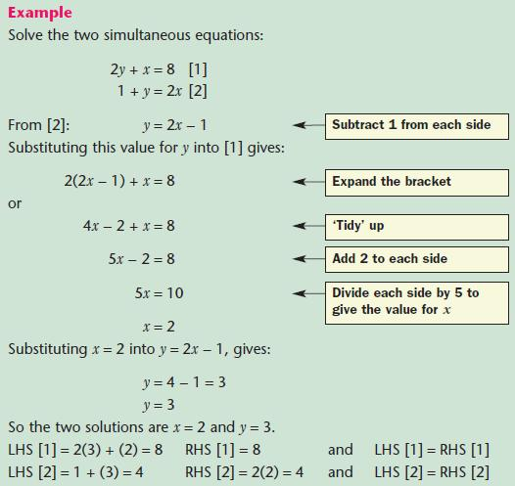

Activity: Find the equation of the straight line through (1,2) that passes through the point of intersection of the lines:
(1) x +2y + 10 = 0 and
(2) 2x - y + 5 = 0
________________________________________________________________________________________________________________________________________________________________________________________________________________________________________________________________________________________________________________________________________________________________________________________________________________________________________________________________________________________________________________________________________________________________________________________________________________________________________________________________________________________________________________________________________________________________________________________________________________________________________________________________________________________________________________________________________________________________________________________________________________________________________________________________________________________________________________________________________________________________________________________________________________________________________________________________________________________________________________________________________________________________________________________________________________________________________________________________________________________________________________
Perpendicular Distance
The perpendicular distance from (x₁,y₁) to the line ax +by + c = 0 is given by
$d= \frac{\left|{ax}_{1 }+ {by}_{1}+ c\right|}{\sqrt{a^{2}+ b^{2}}}$
Example: Find the perpendicular distance of (4, -3) from the line 3x - 4y - 1 = 0
Solution: x₁ = 4 y₁ = -3 a = 3 b = -4 c = -1
$$d= \frac{\left|{ax}_{1 }+ {by}_{1}+ c\right|}{\sqrt{a^{2}+ b^{2}}}$$
$$d= \frac{\left|\left(3× 4\right)+\left(-4×-3\right)-1\right|}{\sqrt{3^{2}+ {(-4)}^{2}}}$$
$$d= \frac{\left|12+12-1\right|}{\sqrt{25}}$$
$$d= \frac{\left|23\right|}{5}$$
$$d= 4\frac{3}{5}$$
Activity: Find the perpendicular distance between (1,2) and
3x + 4y + 2 = 0
____________________________________________________________________________________________________________________________________________________________________________________________________________________________________________________________________________________________________________________________________________________________________________
Angle Between Two Lines
The acute angle θ between two straight lines is given by
$$\tan{θ= \left|\frac{m_{1}- m_{2}}{1+ m_{1}m_{2}}\right|}$$
where $m_{1} and m_{2}$ are the gradients of the lines.
Activity: Find the acute angle between the lines
(1) 2x+ y + 1 = 0
(2) x + y + 4 = 0
____________________________________________________________________________________________________________________________________________________________________________________________________________________________________________________________________________________________________________________________________________________________________________
Ratios
The coordinates of a point P that divides the interval between points (x₁,y₁) and (x₂,y₂) in the ratio m:n respectively are given by
$x= \frac{mx_{2}+ nx_{1}}{m+n}$ and $y= \frac{my_{2}+ ny_{1}}{m+n}$
Activity: Divide the intervals (-1,5) and (0,-4) in the ratio 2:3 internally.
____________________________________________________________________________________________________________________________________________________________________________________________________________________________________________________________________
Topic Test - Past HSC Questions
1. Solve the pair of simultaneous equations
(1) x + y = 2
(2) 2x - y = 7
________________________________________________________________________________________________________________________________________________________________________________________________________________
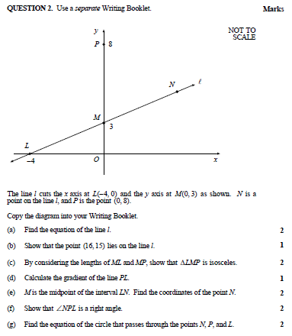
____________________________________________________________________________________________________________________________________________________________________________________________________________________________________________________________________________________________________________________________________________________________________________________________________________________________________________________________________________________________________________________________________________________________________________________________________________________________________________________________________________________________________________________________________________________________________________________________________________________________________________________________________________________________________________________________________________________________________________________________________________________________________________________________________________________________________________________________________________________________________________________________________________________________________________________________________________________________________________________________________________________________________________________________________________________________________________________________________________________________________________________________________________________________________________________________________________________________________________________________________________________________________________________________________________________________________________________
Series and Applications
The infinite sum of a sequence of numbers (or terms) is called a series. A series forms a pattern. Some are easy to see and some are more difficult.
Activity: Find the next 3 terms in each of these series.
(a) 5 + 8 + 11 + _____ + _____ + _____
(b) 2 + 4 + 8 + _____ + _____ + _____
(c) 1 + 1 + 2 + 3 + 5 + 8 + 13 + _____ + _____ + _____
Sigma Notation
Series are often written in Sigma Notation. The Greek letter Sigma (Σ) is like an English S. Here it stands for the sum of a series.
Example: Evaluate
$$\sum_{r=1}^{5}{r^{2}}$$
$\sum_{r=1}^{5}{r^{2}}$ means the sum of the terms where the formula is r² with r starting at 1 and ending at 5.
∴ $\sum_{r=1}^{5}{r^{2}}$ = 1² + 2² + 3² + 4² + 5²
= 1 + 4 + 9 + 16 + 25
= 55
Activity: Evaluate
$$\sum_{r=3}^{9}{r^{2}+ 4}$$
____________________________________________________________________________________________________________________________________________________________
Arithmetic Series
In an arithmetic series each term is a constant amount more than the previous term. The constant amount is called the common difference.
Terms of an Arithmetic Series
$$T_{n}=a+\left(n-1\right)d$$
a = First Term d = Common Difference n = No. of Terms
Example: For the series 6 + 13 + 20 + ... find T₆
$$T_{n}=a+\left(n-1\right)d \\ T_{6}=6+\left(6-1\right)7 \\ T_{6}=41$$
Partial Sum of an Arithmetic Series
$$S_{n}= \frac{n}{2} (a+l)$$
a = First Term l = Last or n^{th} Term n = Number of Terms
In general...
$$S_{n}= \frac{n}{2} [2a+\left(n-1\right)d]$$
Example: Find the sum of 15 terms of the series 4 + 7 + 10 + ....
$$S_{n}= \frac{n}{2} \left[2a+\left(n-1\right)d\right]$$
$$S_{15}= \frac{15}{2} \left[2×4+\left(15-1\right)3\right]$$
$$S_{15}= \frac{15}{2} \left[50\right]= 375$$
Geometric Series
In a geometric series each term is formed by multiplying the preceding term by a constant. The constant is called the common ratio.
Terms of a Geometric Series
$$T_{n}= {ar}^{n-1}$$
a = First Term r = Common Ratio n = Number of Terms
Example: Find the 10th term of the series 3 + 6 + 12 + ...
$$T_{n}= {ar}^{n-1}$$
$T_{10}= {3×2}^{10-1}$ = 1536
Sum of a Geometric Series
The sum of the first n terms of a geometric series is given by the formula:
$$S_{n}= \frac{a (1- r^{n})}{1-r} for \left|r\right|<1$$
a = First Term r = Common Ratio n = Number of Terms
Example: Find the sum of the first 10 terms of the series
3 + 12 + 48 + ... +
$$S_{10}= \frac{3 (1- 4^{10})}{1-4}= \frac{1048575}{1}$$

Sum to Infinity (Limiting Sum)
In some geometric series the sum becomes very large as n increases.
For example: 2 + 4 + 8+ 16 + 32 + 64 + 128
In other geometric series the sum does not increase greatly.
For example: 2 + 1 + $\frac{1}{2}$ + $\frac{1}{4}$ + $\frac{1}{8}$ + ...
When r is a fraction less than 1 (positive or negative) the sum is limited to some finite number.
If |r| < 1 then $S∞ = \frac{a}{1-r}$
Example: Find the sum of the infinite series 6 + 2 + $\frac{2}{3}$
r = $\frac{1}{3}$ So $S∞ = \frac{a}{1-r}$
$S∞ = \frac{6}{1-\frac{1}{3}}=6÷ \frac{2}{3}=9$
Activity: Find the limiting sum of -5 - 1 - $\frac{1}{5}$ - ...
________________________________________________________________________________________________________________________________________________________________________________________________________________________________________________________________________________________________________________________________________________________________________________________________________________________________________________________________________________________________________________________________________
Past HSC Questions
Activity: Anne and Kay are employed by an accounting firm. Anne accepts employment with an initial annual salary of $50,000. In each of the following years her annual salary is increased by $2,500.
Kay accepts employment with an initial annual salary of $50,000. In each of the following years her salary is increased by 4%.
(i) What is Anne's annual salary in her thirteenth year?
____________________________________________________________________________________________________________________________________________________________________________________________________________________________________________________________________
(ii) What is Kay's annual salary in her thirteenth year?
____________________________________________________________________________________________________________________________________________________________________________________________________________________________________________________________________
(iii) By what amount does the total amount paid to Kay in her first twenty years exceed that paid to Anne in her first twenty years?
____________________________________________________________________________________________________________________________________________________________________________________________________________________________________________________________________________________________________________________________________________________________________________
The Tangent to a Curve and the Derivative of a Function
Gradient of a Straight Line
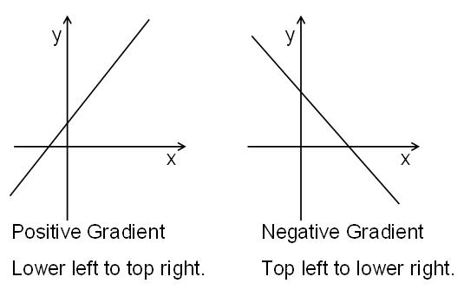
Differentiation from First Principles
The process of finding the gradient of a tangent is called differentiation. A function can be differentiated if the gradient can be found.
Limits
To differentiate from first principles you need to understand limits.
Example: Find
$\lim_{x→2}{\frac{x^{2}- x-2}{x-2}}$ = $\lim_{x→2} \frac{\left(x+1\right)\left(x-2\right)}{\left(x-2\right)}$ = $\lim_{x→2} \left(x+1\right)$
$$= 2+1$$
$=3$
Activity: Evaluate
$$\lim_{x→0} \frac{x^{2}+ 3x}{x}$$
________________________________________________________________________________________________________________________________________________________________________________________________________________________________________________________________________________________________________________________
$$\lim_{x→3} \frac{x^{2}- 3x}{x-3}$$
________________________________________________________________________________________________________________________________________________________________________________________________________________________________________________________________________________________________________________________
Activity: Find an expression in terms of x
$$\lim_{h→0} \frac{x^{2}h-2xh-4h}{h}$$
________________________________________________________________________________________________________________________________________________________________________________________________________________________________________________________________________________________________________________________________________________________________________________________________________________________________
Differentiation as a limit
$$f^{'}\left(x\right)=\lim_{h→0}{\frac{f\left(x+h\right)- f(x)}{h}}$$
Example: Differentiate from first principles to find the gradient of the tangent to the curve y = x² + 3 at the point where x = 1.
$$f^{'}\left(x\right)=\lim_{h→0}{\frac{{(x+h)}^{2}+ 3-(x^{2}+ 3)}{h}}$$
$$f^{'}\left(x\right)=\lim_{h→0}{\frac{x^{2}+ 2xh+h^{2}+ 3-x^{2}- 3)}{h}}$$
$$f^{'}\left(x\right)=\lim_{h→0}{\frac{2xh+h^{2}}{h}} =\lim_{h→0}{\frac{h(2x+h)}{h} =\lim_{h→0}\left(2x+h\right) }$$
$$f^{'}\left(1\right)=\lim_{h→0}{2\left(1\right)+0=2}$$
Activity:

Trigonometric Functions
Area of a minor segment

