Financial Mathematics

FM1 - Earning Money

Wages and Salaries are paid for work done.
- A salary is a fixed payment for a certain period of time, usually a year.
- A wage is usually paid at a set rate per hour.

Example: Chris earns an annual salary of $35 880. Her fortnightly salary is:
Solution: 35 880 ÷ 26 = $1380
  - $690
  - $1380
  - $2990
Example: Rae worked 8 hours at normal time and 2 hours at time and a half. Her normal rate of pay is $9.70 per hour. Her pay for the above time is:
Solution: (8 x 9.70) + (2 x 9.70 x 1.5) = $106.70
A. $77.60
B. $116.40
C. $106.70

Activity: Paul is paid $580 per week. He receives a holiday leave loading of 17.5% for his 4 weeks holiday pay. His total holiday pay is:
________________________________________________________________________________________________________________________________________________________________________________________________________________________________
Activity: Jo works addressing envelopes at home and is paid $25 per 100 envelopes completed, plus $50 to deliver them to the office. She has just delivered 1300 addressed envelopes. Her pay should be:
________________________________________________________________________________________________________________________________________________________________________________________________________________________________

Glossary:

Commission | Is a percentage of sales earned in addition to a wage or salary.
Deductions | Types of deductions include superannuation, union fees and tax instalments.
Gross Pay | Is the total of all pay received before any deductions have been made.
Net Pay | Is equal to the gross pay minus deductions.
Penalty Rates | Penalty rates are usually paid at some multiple of the hourly rate. For example time-an-a-half means 1.5 times the normal hourly rate of pay.
Salary | A salary is a fixed payment for a certain period of time, usually a year.
Taxable Income | Is the income that remains when all allowable tax deductions have been subtracted from the gross income.
Wage | A wage is usually paid at a set rate per hour.

Activity: How much is a commission of 15% on $4280 ________________________________________________________
________________________________________________________
________________________________________________________
Activity: If Mike's Salary is $65 784 pa, what is his Gross Pay per...
a) Month _________________________________________________
________________________________________________________________________________________________________________
b) Fortnight _______________________________________________
________________________________________________________________________________________________________________
c) Week _________________________________________________
________________________________________________________________________________________________________________
d) Day ___________________________________________________
________________________________________________________________________________________________________________
FM2: Investing Money

Simple Interest: I = P x r x n
I = Interest
P = Initial Quantity
r = Interest rate per period expressed as decimal
n = number of periods

Activity: How much is simple interest on $900 at 7% pa for 4 years?
________________________________________________________________________________________________________________________________________________________________________________________________________________________________________________________________________________________
Compound Interest: A = P (1 + r)^{n}

A = Final Balance (Initial amount + Interest)
P= Initial Quantity
n = number of compounding periods
r = interest rate per compounding period as decimal

Activity: Find the final balance if $2000 is invested at 6% pa compounded monthly for 4 years. (Hint: Don't forget to figure out the monthly interest rate)
________________________________________________________________________________________________________________________________________________________________________________________________________________________________________________________________________________________

Annual Percentage Rate (APR):
When an annual interest rate is compounded more than once per year, it's value also become compounded. The APR is mainly used to compare loans with different interest rates and payment intervals. The lower the APR, the lower the cost of the loan to the borrower.
Example: Suppose your credit card charges 18% interest per year, but you have to pay the interest monthly. What is the annual percentage rate? Here the parameters are rate r = 0.18 and the number of compounding periods n = 12. Then the annual percentage rate (APR) r is given by:
So you are actually paying 19.56% pa interest NOT 18%.

I = (1 + $\frac{r}{n}$ )^{n} - 1
I = (1+[0.18/12])¹²-1,
= (1.015)¹²-1,
= 0.195618...,
or an APR of 19.5618%.

Shares & Dividends
If you own shares in a company you are entitled to a portion of the profits. This is known as a dividend. The percentage of this dividend in proportion to the cost of the share is called the dividend yield.

Example: Deeley Development shares paid a dividend yield of 5%.
If you owned 700 shares in Deeley Development, with a market value of $3.80, how much should your dividend be?
Solution:
Price of shares x dividend yield x number of shares = dividend
3.80 x $\frac{5}{100}$x 700 = $133
The dividend will be $133.00

Activities: Evaluate the following Questions.

- An interest rate is given as 4.8% per annum. This is the same as:
  - 0.4% per month and 1.2% per quarter.
  - 0.6% per month and 1.8% per quarter.
  - 0.4% per month and 1.6% per quarter.
- The formula for compound interest is A = P(1 + r)^{n}.
For an investment of $5000, over a period of 2 years with a monthly interest rate of 0.8%, the calculation should be:
  - A = 5000 (1 + 0.008)²⁴
  - A = 5000(1 + 0.8)²⁴
  - A = 5000 (1 + 0.08)²
- Option 1: Invest $1270 every six months at 4% per half-year.
Option 2: Invest $2540 every year at 8% per year.
Which option would produce the most money after 5 years?
  - Option 1.
  - Option 2.
  - They are of equal value.
- As a result of inflation the value of a beach house increased by 3.5% each of the last two years. It was bought for $190 000 two years ago. Calculate the new anticipated value. (Hint: When you are appreciating an item you use simple interest)
  - $203 300
  - $176 933
  - $203 533
- Jo inherited an antique tie pin. It was valued at $1350. Each year its value appreciated by 5%.
Approximately how much was the tie pin expected to be worth 5 years later?
  - $1723
  - $1045
  - $1688

FM3: Taxation

Taxation is necessary because governments use money collected from income and business tax to help pay teachers, fix roads, maintain hospitals and help people with disabilities and people who are unemployed or homeless.

Taxable income is calculated by your annual gross income minus deductions. Deductions include any allowances like for cleaning or purchasing work uniforms, petrol/transport to and from work. Once deductions are taken away the amount of tax you have to pay is calculated using your taxable income.

Example: From the gross fortnightly pay, the following deductions are taken: $11 for union fees, $27.05 for medical fund, $373.46 for superannuation contribution and $439.42 for taxation.
The total deductions made per fortnight is:
  - $850.93
  - $840.04
  - $411.51
Activity: Evaluate a Medicare levy of 1.5% on $32 690 ________________________________________________________
________________________________________________________
Activity: Use the tax table to find the tax payable on
a) $5 600 ________________________________________________ ________________________________________________________b) $16 420 _______________________________________________
________________________________________________________c) $42 185 _______________________________________________
________________________________________________________

Taxable Income | Tax Payable
$0 - $6 000 | nil
$6 001 - $20 000 | 17 cents for every dollar over $6000
$20 001 - $50 000 | $2380 + 30 cents for every dollar over $20 000
Marianne has deductions taken from her pay each week.
Which of these deductions will NOT reduce her taxable income:
- Rent.
- Union fees.
- Donations to Red Cross.

The medical levy is 1.5% of the taxable income.
If the gross income was $47,480 and allowable deductions came to $1,230, the medicare levy would amount to:
- $712.20
- $693.75
- $18.45
Example: After the 10% GST was added to the earnings, they cost $242. What was the cost without GST?
Solution: 242 = 110%
242 = 1.1
$\frac{242}{1.1}$ = $220

Activity: After 10% GST was added to the earnings, they cost $99. What was the cost without GST?
________________________________________________________________________________________________________________________________________________________________________________________________________________________________________________________________________________________________________________________________________________________________________________________________________
Data Analysis

DA1 & DA2 - Statistics & Data Collection and Sampling

Types of Data
Qualitative Data: Data not given numerically (eg. Favourite Food/Colour) | Quantitative Data: Data given numerically (eg. Number of siblings, Shoe Size)
 | Continuous  Numerical data which can take any value. (Height, Mass, Length) | Discrete  Numerical data which can only take specific values.  (Shoe Size, No. of Cars)

Activity: Match the data to their type of data...
Star Sign |  | Qualitative
Weight |  | Quantitative
Age |  | Continuous
Shoe Size |  | Discrete

Data Collection Methods
Collection Method | Definition
Population/Census | The entire population (most accurate but time consuming and expensive)
Random Sample | is chosen without any reason. Not always an accurate representation of the population.
Stratified Sample | has a fair representation of all different subgroups in population.
Systematic Sample | is chosen according to a chosen system or pattern.

Activity: Every five years the Australian Bureau of Statistics conducts a census. Which of the following is a reason a census is useful to government planning:
  - It collects information from every member of the community.
  - It employs a lot of people and reduces the unemployment rate in an election year.
  - It will find all of the people who are avoiding paying taxes.

Activity: When conducting a questionnaire for a statistical inquiry it is important to consider how the questions are asked because: (choose the MOST correct response)
  - A badly worded question will make people angry and this will affect how they answer.
  - The way the question is worded can influence how it is answered.
  - If the questionnaire is too long you won't get many people to respond.
Activity: Statistics are important to industry. One reason for this is:
  - By collecting and testing a sample of their product they can be sure of how many defective items were produced.
  - By collecting and testing a sample of their product they can determine which worker is not as productive as the others.
  - By collecting and testing a sample of their product they can get some indication if their standards are being maintained.
Activity: When collecting statistical data it is said you must consider issues of privacy and ethics. This means you should:
- Not allow anyone else to know the results of your survey.
- Have your survey checked by the police before going ahead with it.
- Be conscious of the sensitivities your questions may trigger.

Activity: The Australian Bureau of Statistics is:
- Run by the government of the day
- Independent of government influences.
- A branch of the Australian Taxation Office.

Activity: You are a NSW businessman, selling soccer balls designed to meet NSW Soccer Federation standards. You want a survey done for your business. A suitable population from which to take a random sample would be:
- The whole population of Australia.
- All people enrolled in a NSW soccer team.
Activity: Which of these situations would NOT be a likely valid reason for not taking a representative sample.
- The population is so small you can survey them all.
- You can work out the data by just asking a few people you know.
- The population is large but the data you want is already available from the ABS.

Activity: Which of the following is an example of categorical data?
- People’s opinions about TV shows.
- Shoe sizes.
- The length of long stemmed roses.

Activity: A stratified sample is one where...
- Each member of the group is given a number and the selection is made using a random number generator.
- Each member of the group is given a number to enable the group to be divided into smaller groups. One person is chosen from each of these smaller groups.
- The group is divided into smaller groups using some rule eg age. There is then a selection made from each group.

DA3 - Displaying single data sets

Summary Statistics

Statistic | Definition | Example
Mean / Average | Add up all of the pieces of data and divide the total by the number of data points. | Find the mean of the data set 5,6,7,3,9  5+6+7+3+9 = 30  30 ÷ 5 = 6  The mean is 6
Mode | The MOST popular number in a data set or the number that occurs the most. | Find the mode of the data set 4,5,5,6,7  5 is the mode because it occurs twice.
Median | The middle number of a chronological data set.  NB. You must rearrange the numbers in order. | Find the median of the data set 6,7,3,4,5  Rearrange the set in order... 3,4,5,6,7  Median is 5.
Range | The range of scores in the data set. Aka The highest number - the lowest number. | Find the range of the data set 4,6,9,11,2  The range is 11-2 = 9

Box and Whisker Plots:
A box-and-whisker plot can be useful for handling many data values. They allow people to explore data and to draw informal conclusions when two or more variables are present. It shows only certain statistics rather than all the data. The first step in constructing a box-and-whisker plot is to first find the median, the lower quartile and the upper quartile of a given set of data. Example: The following set of numbers are the amount of marbles fifteen different boys own (they are arranged from least to greatest).

18 27 34 52 54 59 61 68 78 82 85 87 91 93 100

First find the median. The median is the value exactly in the middle of an ordered set of numbers.

68 is the median

Next, we consider only the values to the left of the median: 18 27 34 52 54 59 61. We now find the median of this set of numbers. Remember, the median is the value exactly in the middle oa an ordered set of numbers. Thus 52 is the median of the scores less than the median of all scores, and therefore is the lower quartile.

52 is the lower quartile

Now consider only the values to the right of the median: 78 82 85 87 91 93 100. We now find the median of this set of numbers. The median 87 is therefore called the upper quartile.

87 is the upper quartile

You are now ready to find the interquartile range (IQR). The interquartile range is the difference between the upper quartile and the lower quartile. In our case the IQR = 87 - 52 = 35. The IQR is a very useful measurement. It is useful because it is less influenced by extreme values, it limits the range to the middle 50% of the values.

35 is the interquartile range

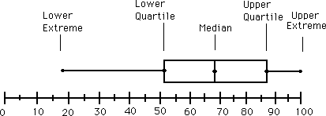
Stem and Leaf Plot

What is A Stem and Leaf Plot Diagram?
Data can be shown in a variety of ways including graphs, charts and tables. A Stem and Leaf Plot is a type of graph that is similar to a histogram but shows more information. The Stem-and-Leaf Plot summarizes the shape of a set of data (the distribution) and provides extra detail regarding individual values. The data is arranged by place value. The digits in the largest place are referred to as the stem and the digits in the smallest place are referred to as the leaf (leaves). The leaves are displayed to the right of the stem. Stem and Leaf Plots are great organizers for large amounts of information.
What Are They Used For?
They are usually used when there are large amounts of numbers to analyse. Series of scores on sports teams, series of temperatures or rainfall over a period of time, series of classroom test scores are examples of when Stem and Leaf Plots could be used.
Test Scores out of 100
Stem | Leaf
10 | 0
9 | 0, 1, 3, 8
8 | 1, 9, 9
7 | 0, 1, 4
6 | 4, 5, 8
5 | 2, 3

52, 53, 64, 65, 68, 70, 71, 74, 81, 89,
89, 90, 91, 93, 98, 100

Activities:
- The following marks represent:
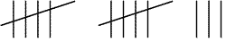
  - 3
  - 13
  - 23
- This is an example of:
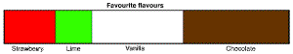
  - A sector graph
  - A histogram
  - A bar graph
- When graphing this data a suitable scale for the H values would be:
n | 1 | 2 | 3 | 4 | 5
H | 2 | 8 | 6 | 2 | 1

  - From 0 to 12 with a mark for each even number.
  - From 0 to 20 with a mark for every 5 points.
  - From 1 to 15 with a mark for every point.
- This graph is misleading because:
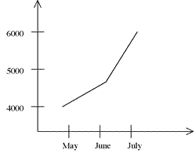
  - By starting the vertical axis at 3000 it over-emphasises the growth.
  - There are numbers on one axis and words on the other.
  - You can’t tell what happened in April.
- This is a stem and leaf plot for 12 items.
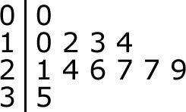
The range for the data is:
  - 25
  - 9
  - 35
- In statistics, a radar chart is used to:
  - Check traffic flows.
  - Graph data.
  - Predict weather patterns
- If your test result is recorded as being in the 9th decile, this means:
  - At least 10% of students scored higher than you.
  - You scored at least 90%
  - Your score was between 80% and 90%
- The interquartile range of a set of data contains:
  - 25% of the data.
  - The middle quarter of the data.
  - 50% of the data.
- This graph could be an example of:
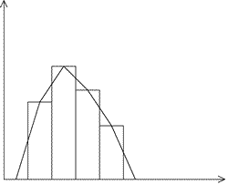
  - An ogive.
  - Cumulative frequency.
  - A frequency distribution.
- The median for this set of data is approximately:
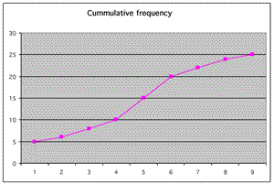
  - 12.5
  - 15
  - 9
- Given that the five number summary for a set of data is 5, 15, 21, 29, 49 which statement would be true?
  - The median is in the middle of the upper and lower quartiles.
  - The range for the data is 44.
  - The interquartile range is 50.
- The box and whisker plot for the data in the previous question 5, 15, 21, 29, 49 will look like:
  - 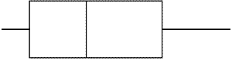
  - 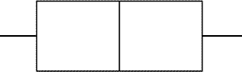
  - 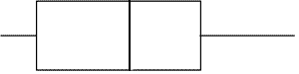
- Two surveys were done. One was favourite icecream flavours and the other was costs for different brands of icecream.
From the choices offered the best choice for displaying these two sets of data would be:
  - A histogram for the flavours and a pie chart for the costs.
  - A bar chart for both the flavours and the costs.
  - A bar chart for the flavours and a histogram for the costs.
- A sector graph (pie chart) is not very effective when:
  - A sector is very similar but not equal in size to another.
  - You don’t have enough colours.
  - The total is not easily divided into 360 degrees.

DA4 Summary Statistics

Mean: Add all the scores together and divide by the number of scores.
Mode: The most frequent score (the most popular score).
Median: The median is the middle score (if the set of scores is even take the average of the two middle scores).
Range: The Highest score subtracted by the lowest score.

Standard Deviation:
The Standard Deviation is a measure of how spread out numbers are.
Its symbol is σ (the greek letter sigma)
The formula is easy: It is the square root of the Variance.

Variance:
The Variance is defined as:

The average of the squared differences from the Mean.

To calculate the variance follow these steps:

- Work out the Mean (the simple average of the numbers)
- Then for each number: subtract the Mean and square the
result (the squared difference).
- Then work out the average of those squared differences.

Example: You and your friends have just measured the heights of your dogs (in millimetres):
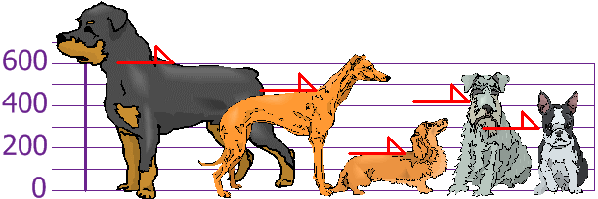
The heights (at the shoulders) are: 600mm, 470mm, 170mm, 430mm and 300mm.
Find out the Mean, the Variance, and the Standard Deviation.
Your first step is to find the Mean:
Answer:
Mean = | 600 + 470 + 170 + 430 + 300 | = | 1970 | = 394
Mean = | 5 | = | 5 | = 394
so the mean (average) height is 394 mm. Let's plot this on the chart:
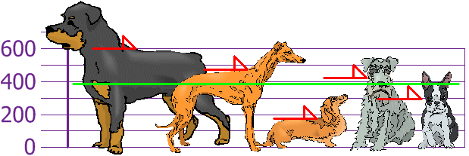
Now, we calculate each dogs difference from the Mean:
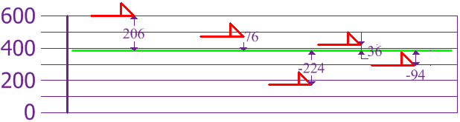
To calculate the Variance, take each difference, square it, and then average the result:
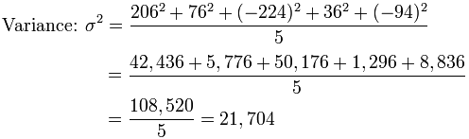
So, the Variance is 21,704.
And the Standard Deviation is just the square root of Variance, so:
Standard Deviation: σ = √21,704 = 147.32... = 147 (to the nearest mm)

And the good thing about the Standard Deviation is that it is useful. Now we can show which heights are within one Standard Deviation (147mm) of the Mean:
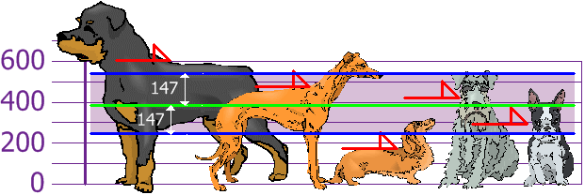

So, using the Standard Deviation we have a "standard" way of knowing what is normal, and what is extra large or extra small.

MM1 Units of Measurement and Applications

Conversions
seconds ÷ 60 | minutes ÷ 60 |  |  | hours ÷ 24 |  |  | days ÷7 |  |  | weeks
grams ÷ 1000 |  |  | kilograms ÷1000 |  |  | tonnes ÷1000 |  |  | kilo-tonnes
millimetre ÷10 |  | centimetre ÷100 |  |  | metre ÷1000 |  |  | kilometre

Activity: Fill in the blanks
245 cm | __________m | 300 g | ___________kg
103 seconds | __________ h | 3 days | _________mins

Accuracy of Measurement
The accuracy of measurement is determined by the accuracy of the instrument and that of the person doing the measuring.

TIP! When answering a question make sure to write the WHOLE answer out first before rounding to the number of decimal places or significant figures required.

Scientific Notation
3 400 000 = 3.4 x 10⁶
0.00356 = 3.56 x 10⁻³

Activity: Convert these measurements to scientific notation

5 342 000 cm = ____________cm 89 456 kg = _______________kg

534 m = __________________m 2 678 km = _______________km

0.0658 m = _______________m 0.00489 kg = ______________kg

Ratios

Ratios help when determining how to scale things up and down like a recipe for cooking.
Example: The ratio of flour to egg to water in a recipe for pasta is 3:4:1. If I want to make 160g of pasta how much of each ingredient do I need?
Total of 8 parts in the ratio.
160g ÷ 8 = 20g ∴Each part = 20g
(3 x 20) : (4 x 20) : (1 x 20)
60g of flour 80g of egg 20g of water

Activity: To make a cake that weighs 2kg you need 4 ingredients sugar, flour, eggs and milk in the ratio 3:4:2:1, respectively.
Find how much of each ingredient you will need.
________________________________________________________________________________________________________________________________________________________________________________________________________________________________________________________________________________________________________________________________________________________________________________________________________

Rates
Rates most commonly come in the form of a unit of measurement verses a unit of time (eg. km/h or m/s). Other examples where this does not happen include $/kg, cents/g, etc.

Example: If I am travelling at 60km/hour how many km do I travel in 3 hours?
Solution: $\frac{60km}{hour}$ x $\frac{3 hours}{1}$ = 180km

Converting Rates

When you do any measuring sometimes you need to convert measurements so that you can compare them.

Example: Convert 24m/s to km/hour
Solution: Pick one of the measurements to convert first.
24m/s = 1440m/min = 86400m/hour
Convert 86400m into km (÷1000)
= 86.4km/hour

Activity: Convert the following

25g/sec kg/hour
________________________________________________________________________________________________________________________________________________________________________________________________________________________________________________________________________________________
36mL/min L/day
________________________________________________________________________________________________________________________________________________________________________________________________________________________________________________________________________________________

55c/g $/kg
________________________________________________________________________________________________________________________________________________________________________________________________________________________________________________________________________________________

MM2 Applications of Perimeter, Area and Volume

Formulae

Shape | Picture | Perimeter | Area
Triangle | 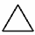 | P=side + side + side | A=$\frac{1}{2}bh$
Square | 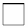 | P= 4 x s | A=s²
Rectangle |  | P=2l + 2b | A=l x b
Circle | 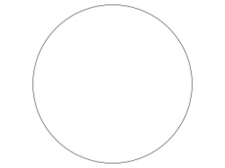 | C=2πr | A=πr²
Ellipse | 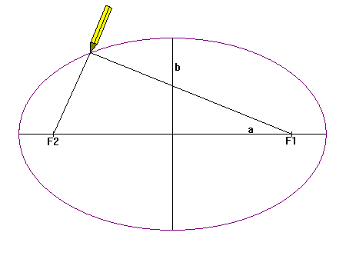 | n/a | A=πab
Annulus | 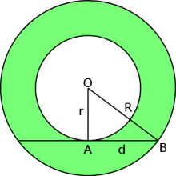 | n/a | A=π(R² - r²)
Sector of a Circle | 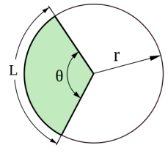 | P = Arc length + (2 x radius)  aka  P=$\frac{θ}{360}2πr+2r$ | A = $\frac{θ}{360}πr^{2}$
Volume

Name | Picture | Formula
Cube | 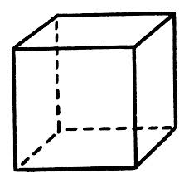 | V = s³
Rectangular Prism | 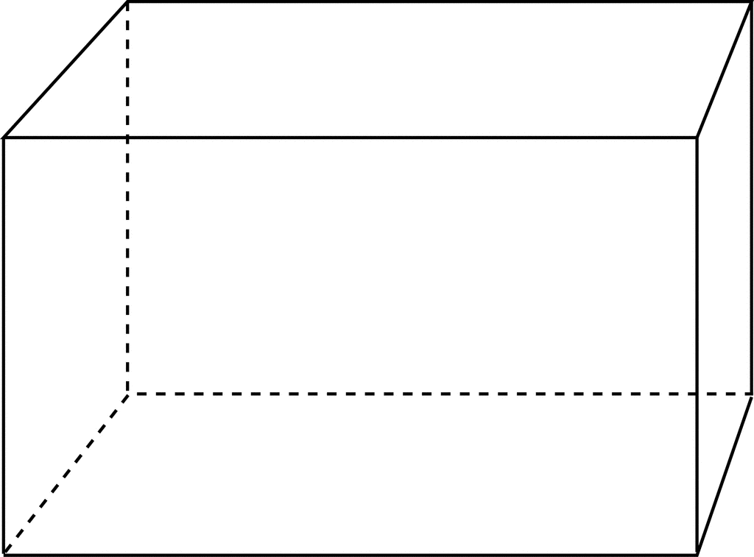 | V = lbh
Cone | 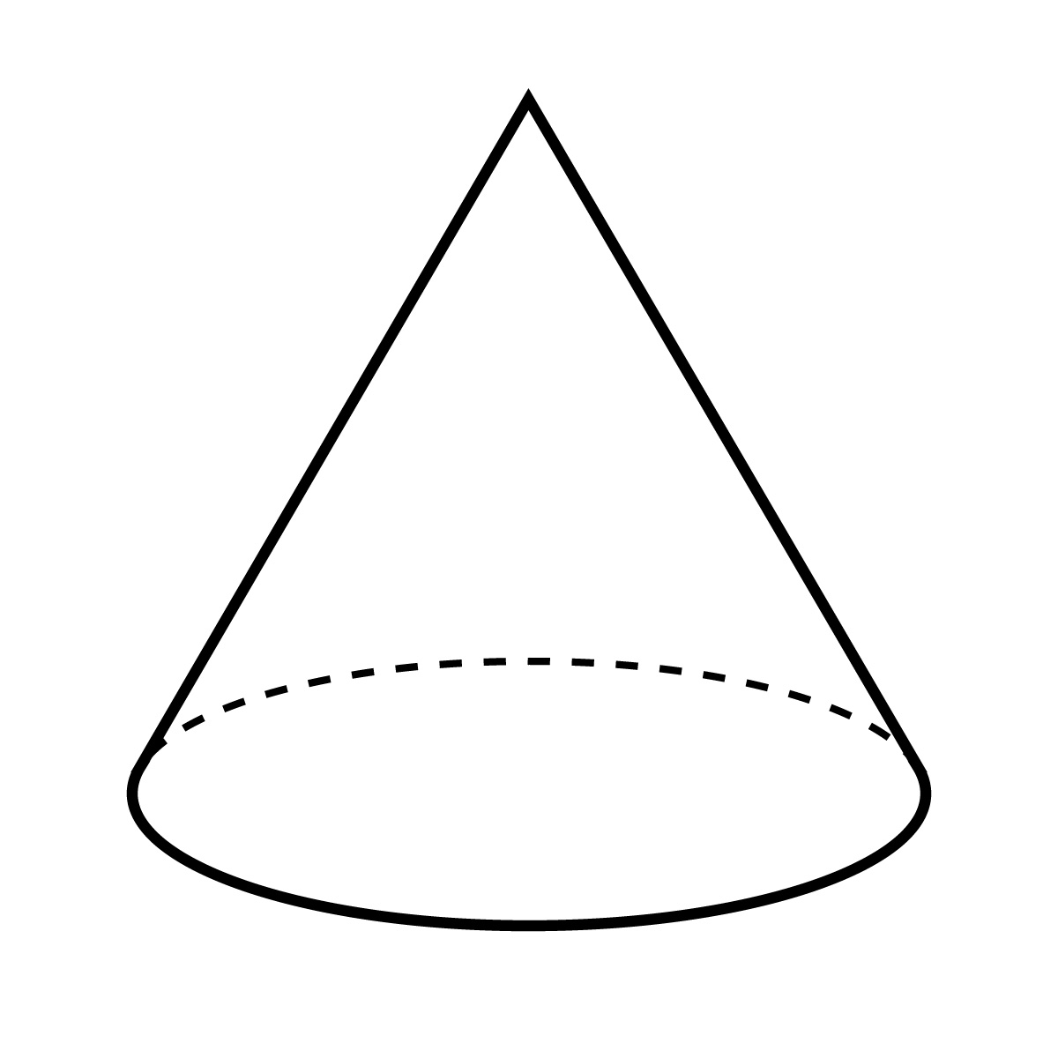 | V = $\frac{1}{3}πr^{2}h$
Cylinder | 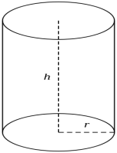 | V = $πr^{2}h$
Pyramid | 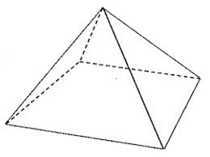 | V = $\frac{1}{3}Ah$  where A = Area of base.
Sphere | 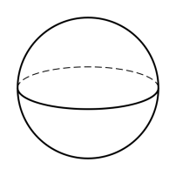 | V = $\frac{4}{3}πr^{3}$

Activities: Answer the following Past HSC Questions
The perimeter of a rectangle is 84cm. The length of the rectangle is twice the breadth. What is the length of the rectangle?
________________________________________________________________________________________________________________________________________________________________________________________________________________________________________________________________________________________
A circular running track has a diameter of 50m. How many times must Jason go around this track to run 1000m?
________________________________________________________________________________________________________________________________________________________________________________________________________________________________________________________________________________________
A water tank has a volume of 10.2m³. Calculate the number of litres of water required to fill the tank. (1m³ = 1000L)
________________________________________________________________________________________________________________________________________________________________________________________________________________________________________________________________________________________________________________________________________________________________________________________________________
This tank is to be filled with a garden hose. The hose fills a10L bucket in 25 seconds. Calculate, to the nearest hour, the time required to fill the tank.
________________________________________________________________________________________________________________________________________________________________________________________________________________________________________________________________________________________________________________________________________________________________________________________________________________________________________________________________

MM3: Similarity of 2-Dimensional Figures
Trigonometry
Trigonometric Ratios
Sine | sinθ | =$\frac{opposite}{hypotenuse}$
Cosine | cosθ | =$\frac{adjacent}{hypotenuse}$
Tangent | tanθ | =$\frac{opposite}{adjacent}$
Cosecant | cosecθ | =$\frac{hypotenuse}{opposite}$ | $$\frac{1}{sinθ}$$
Secant | secθ | =$\frac{hypotenuse}{adjacent}$ | $$\frac{1}{cosθ}$$
Cotangent | cotθ | =$\frac{adjacent}{opposite}$ | $$\frac{1}{tanθ}$$

Complementary Angles
Sine θ | =cos(90⁰ - θ)
Cosine θ | =sin(90⁰ - θ)
Tangent θ | =cot(90⁰ - θ)
Cosecant θ | =sec(90⁰ - θ)
Secant θ | =cosec(90⁰ - θ)
Cotangent θ | =tan(90⁰ - θ)

Rounding Off Angles
60 minutes | = 1 degree | (60' = 1⁰)
60 seconds | = 1 minute | (60" = 1')

If the minute or second is below 30 it stays the same, if it is above 30 you round up.
Finding a Missing Variable
Trigonometry is used to find an unknown side or angle of a triangle.
Activity: Find θ to the nearest degree.
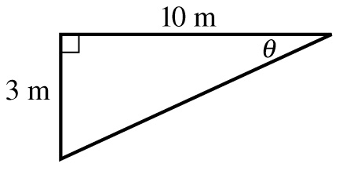

Activity: Find the value of x.
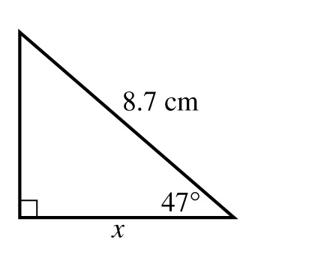
Activity: For the following, evaluate θ correct to the nearest minute, sin θ = 0.422

Activity: Identify the complementary angle of Cosec 47⁰

Angle of Elevation
The angle of elevation is used to measure the height of tall objects that cannot be measured directly, for example a tree, cliff, tower or building.
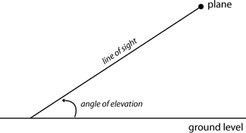
Angle of Depression
The angle of depression is the angle formed when looking down from a high place to an object below.
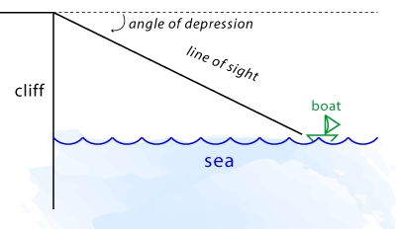

Activity: The angle of depression from the top of a 20m building to a boy below is 61⁰39'. Draw a diagram and determine how far is the boy from the building to 1 decimal place?

Activity: The angle of elevation of a tower is 39⁰44' when measured at a point 100m from its base. Draw a diagram and find the height of the tower, to 1 decimal place.

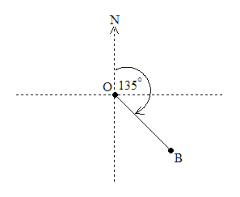
Bearings
True bearings measure angles in a clockwise direction beginning at north.
Example: Sketch the diagram when B is on a bearing of 135⁰ from O.
Solution: See figure 1

Figure 1
Activity: Sketch the diagram of A is on a bearing of 245⁰ from B.

Activity: A plane flies north from Sydney for 560km, then turns and flies east for 390km. What is its bearing from Sydney, to the nearest degree?

Exact Ratios
A right angles triangle with one angle of 45⁰ is isosceles. The exact length of its hypotenuse can be found.
 | 30⁰ | 45⁰ | 60⁰
sinθ | $$\frac{1}{2}$$ | $$\frac{1}{\sqrt{2}}$$ | $$\frac{\sqrt{3}}{2}$$
cosθ | $$\frac{\sqrt{3}}{2}$$ | $$\frac{1}{\sqrt{2}}$$ | $$\frac{1}{2}$$
tanθ | $$\frac{1}{\sqrt{3}}$$ | 1 | $$\sqrt{3}$$

Activity: Find the exact values in all questions.
- sin60⁰ + cos60⁰ =

- cosec45⁰ =
- 2 sec60⁰ =
- cot30⁰ + cot60⁰ =

Types of Triangles
Name | Picture | Characteristics
Equilateral | 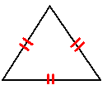 | All equal sides and angles.
Scalene | 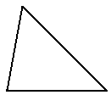 | No equal sides and angles
Isosceles | 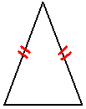 | Two equal sides with corresponding equal angles.
Right Triangle | 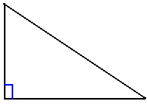 | Triangle with a right angle.

Angle Sum of a Triangle
The sum of the interior angles in any triangle is 180⁰
Exterior Angle of a Triangle
The exterior angle of any triangle is equal to the sum of the two opposite interior angles.
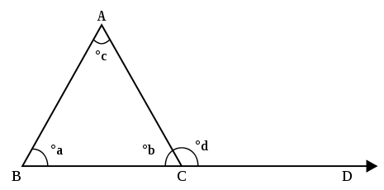
aº + cº = dº
Congruent Triangles
Two triangles are congruent if they are exactly the same shape and size. All pairs of corresponding sides and angles are equal.
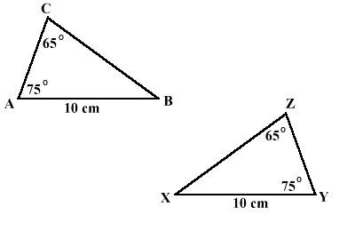
Congruency Tests
SSS | All 3 pairs of corresponding sides are equal.
SAS | Two pairs of corresponding sides and their included angles were equal.
AAS | Two pairs of angles and one pair of corresponding sides are equal.
RHS | Both have a right angle, their hypotenuses are equal and one other pair of corresponding sides are equal.
Activity: Circle the pairs of triangles that are congruent. If they are congruent what test would you use to prove them congruent.
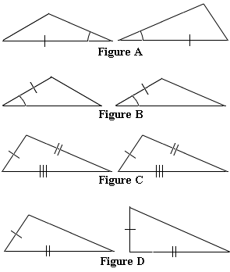
Similar Triangles
Triangles are similar if they have the same angles but different sized sizes that are in proportion to one another.
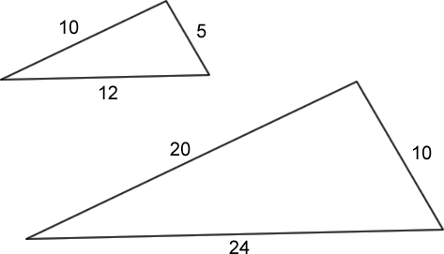

Similarity Tests
Two triangles are similar if:
- 3 pairs of corresponding angles are equal.
- 3 pairs of corresponding sides are in proportion.
- 2 pairs of sides are in proportion and their included angles are equal.

Activity: Are these triangles similar? If so find h to 1 decimal place (Give reasons)
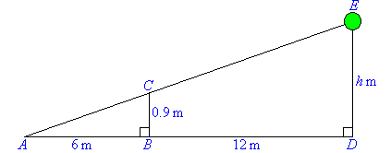
____________________________________________________
____________________________________________________
____________________________________________________
____________________________________________________
____________________________________________________
____________________________________________________
AM1 Algebraic Manipulation

Decimals, Fractions & Percentages:
Decimal | Fraction | Percentage
0.1 | 1/10 | 10%
0.2 | 2/10 = 1/5 | 20%
0.25 | 25/100 = 1/4 | 25%
0.3333333.... | 1/3 | 33.333333... %
0.5 | 1/2 | 50%
0.75 | 75/100 = 3/4 | 75%
1.0 | 1/1 = 2/2 = 6/6 | 100%

Powers and Roots
Power (Index) | Expanded Notation
6⁵ | 6 x 6 x 6 x 6 x 6
3⁴ | 3 x 3 x 3 x 3

Index Laws
RULE | ACTIVITY
a^{m} x a^{n} = a^{(m + n)} | g⁴ x g⁵ =
a^{m}÷ a^{n} = a^{(m-n)} | g⁵ ÷ g³ =
(a^{m})^{n} = a^{mn} | (g⁵)⁴ =
(ab)^{n} = a^{n}b^{n} | (gf)⁴ =
${\left(\frac{a}{b}\right)}^{n}$= $\frac{a^{n}}{b^{n}}$ | $${\left(\frac{a}{b}\right)}^{6}=$$
a⁰ = 1 | (3b)⁰ =  3b⁰ =
a^{-n} = $\frac{1}{a^{n}}$ | a⁻⁶ =

1. Simplify:
a) a² - a³ + 6 + 2a² - 3a³ = ______________________________
b) 2x × 3xy = _________________________________________
c) (-3a²)² = __________________________________________
2. If a=2, b=-1, c=3 find:
a) 3a + 2b = _________________________________________
b) ab ÷ c = ___________________________________________
c) 2a²b - 3c² = ________________________________________
3. Expand:
a) (x+7)(x-3) = ________________________________________
____________________________________________________
b) (x-5)(x+9) = _______________________________________
____________________________________________________
4. Expand and collect like terms:
a) 2a - 7b - a + 2b = ___________________________________
___________________________________________________
b) 3(x + 3) - 2(x - 2) = __________________________________
____________________________________________________
c) (x + 7)(x - 1) = ______________________________________
____________________________________________________
Example: Given that I = Prn, find I when P = 8000, r = 0.075 and n = 4
Solution: I = Prn
I = 8000 x 0.075 x 4
I = 2400

Activity: If v = u + at, find v when u=14, a=10 and t=3
________________________________________________________________________________________________________________________________________________________________________________________________________________
Activity: A = $\frac{θ}{360}x πr^{2}$. Find A, correct to 2 decimal places, when θ = 75 and r = 11.
________________________________________________________________________________________________________________________________________________________________________________________________________________

Activity: Solve $7x-8=13$
________________________________________________________________________________________________________________________________________________________________________________________________________________

Activity: Solve $8p+3=3p+19$
________________________________________________________________________________________________________________________________________________________________________________________________________________

Example: If F=ma, find m when F=245 and a =9.8
Solution:
245 = m × 9.8
245 ÷ 9.8 = m
m = 2401

Activity: Solve$5\left(4h-3\right)= 12-2\left(6-h\right)$
________________________________________________________________________________________________________________________________________________________________________________________________________________________________________________________________________________________________________________________________________________________________________________________________________________________________

Activity: Solve $\frac{k+5}{2}= \frac{k-4}{5}$
________________________________________________________________________________________________________________________________________________________________________________________________________________________________________________________________________________________________________________________________________________________________________________________________________________________________

AM2 Interpreting Linear Relationships

