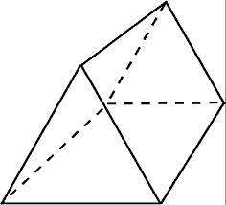
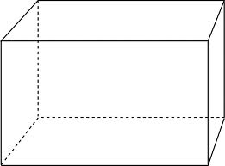
Task: Using the Butchers paper provided practice drawing the nets of the 3D shapes below. When you have perfected this, try drawing a net on some cardboard and constructing your own 3D shape.

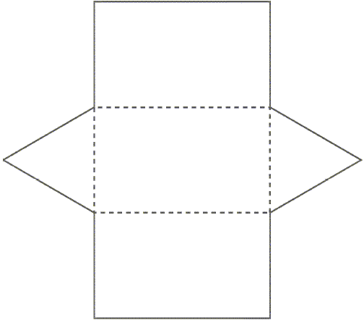
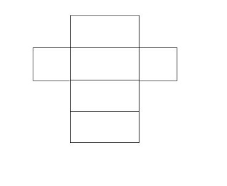
Hint: Remember when you constructed your 3D nets they had little tabs to help you glue your net together. You may want to add those in on your design.

WALT: How to make a net of a 3D Shape.
TIB: Learning how to make a 3D shape will help you understand 3D shapes better.
WILF: Neat work and straight lines drawn with rulers.

