Angle | Picture | Rule
Alternate Angle | 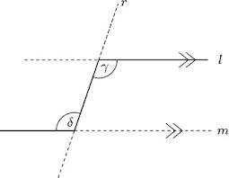 | Alternate Angles are Equal
Corresponding Angles | 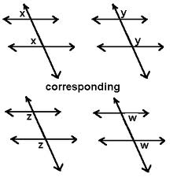 | Corresponding Angles are Equal
Co-interior Angles | 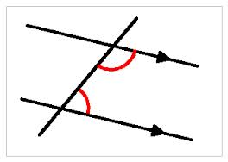 | Co-interior Angles are Supplementary (aka they add to 180⁰)
Vertically Opposite Angles | 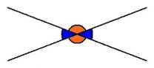 | Vertically opposite angles are equal.
Straight Line Angles | 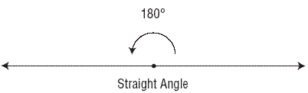 | Straight line angles add to give 180⁰
Right Angles | 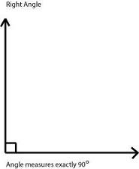 | Right angles add to give 90⁰

Shape | Picture | Angle Sum
Triangle | 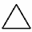 | 180⁰
Quadrilateral  (Any 4-sided shape) | 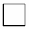 | 360⁰
Pentagon | 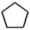 | 540⁰
Hexagon |  | 720⁰
Heptagon | 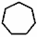 | 900⁰
Octagon | 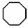 | 1080⁰

