Fractions Topic Test
- Write the following fractions in words, eg. $\frac{1}{2}=One half$
$\frac{3}{4}=_________________________________$ $\frac{2}{5}=_________________________________$
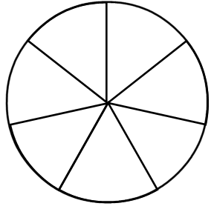
- Colour in the following fractions on the diagrams provided.
$\frac{1}{4}$ $\frac{4}{7}$

- Write a fraction which is equivalent (equal to) $\frac{1}{2}$
- $\frac{3}{7}+ \frac{2}{7}=$
- $\frac{17}{20}- \frac{12}{20}$ $=$
- $\frac{3}{5}+ \frac{}{5}= \frac{4}{5}$
- $\frac{}{11}- \frac{3}{11}= \frac{7}{11}$

- Using the below fractions, write down 3 ways you can create the fraction $\frac{9}{12}$
$\frac{1}{12 } \frac{2}{12} \frac{3}{12} \frac{4}{12} \frac{5}{12} \frac{6}{12}$
$$\frac{7}{12} \frac{8}{12} \frac{9}{12} \frac{10}{12} \frac{11}{12} \frac{12}{12}$$

- $\frac{3}{6}+ \frac{1}{3}= \frac{}{}$
- $\frac{1}{4}+ \frac{2}{3}= \frac{}{}$
Mark: / 14
Date: ____________
Marked by: Miss Rebecca Apps

