Graph Types

Sector graphs
Sector graphs, also known as pie charts, are displayed as a circle which has been broken up into sectors. Each sector represents part of a whole. For this reason sector graphs are useful when representing percentages. For example:
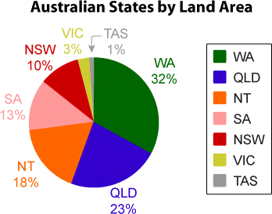
A clear heading and descriptive labels must be provided in order for the graph to be effective.
As each sector represents a percentage, the size of the sector is determined as a percentage of the circle. In the above example, NSW makes up 10% of Australia's land area. Therefore, NSW also takes up 10% of the circle (10% of 360º), which is equal to 36º.
The working out for each sector is outlined in this table:
Australian State | % of Land Area (approximate) | Angle at the Centre of the Sector Graph
Western Australia | 32% | 115.2º
Queensland | 23% | 82.8º
Northern Territory | 18% | 64.8º
South Australia | 13% | 46.8º
New South Wales | 10% | 36º
Victoria | 3% | 10.8º
Tasmania | 1% | 3.6º
TOTAL | 100% | 360º

Divided bar graph
Divided bar graphs are very similar to sector graphs. The divided bar graph provides a comparison between quantities by breaking the bar up into sectors based on percentages. For example:
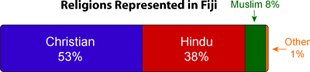
The graph simply shows the religions of Fiji as percentages. The bar is broken up into matching percentages. The working out for this is set out in the following table:
Religion | Percentage of Fijian Population (approx) | Representative Length on a 12cm Bar Graph
Christian | 53% | 6.36 cm
Hindu | 38% | 4.56 cm
Muslim | 8% | 0.96 cm
Other | 1% | 0.12 cm
TOTAL | 100% | 12.00 cm

Line graphs
Line graphs are very common and are often used to show changing information. Line graphs deal with data that is continuous. The graph must have a clear heading and each axis has to be labelled. For example:
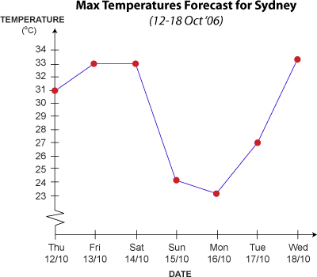
This line graph shows changing temperature over time.

Conversion graphs
Conversion graphs are line graphs which are used to convert one unit of measurement into another. For example, degrees Celsius may be converted into degrees Fahrenheit:
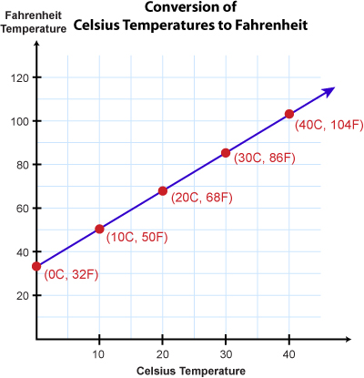
The graph must have a clear heading and each axis has to be labelled. The line on the graph plots all of the points where the temperatures equal each other. The line can then be used as a quick reference to convert the temperatures.

Step graphs
The step graph is a specific type of line graph. It caters for the display of data which falls into separate intervals that do not overlap.
Data is displayed in steps. At the point where the intervals would normally overlap, an open circle is used to indicate that the graph is discontinuous. A closed circle appears at the opposite end of the step.
Once again, a clear heading and labelled axis must be provided. For example:
